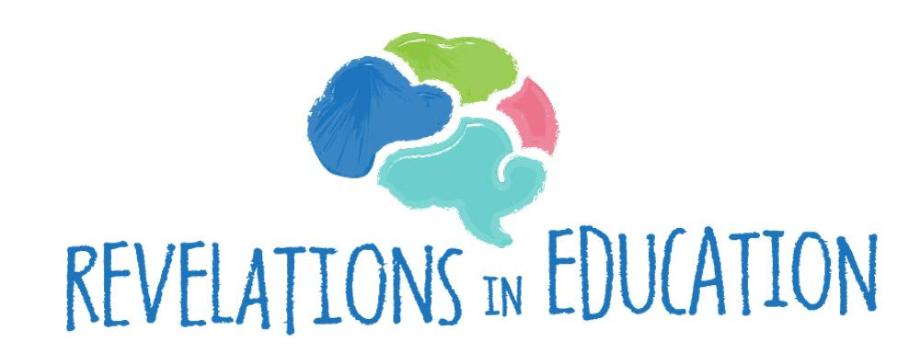
BRAIN ALIGNED STRATEGIES

Relational, Preventive Discipline
Meeting students and staff in their brain state is critical for our emotional, mental and physiological well-being! This chart shares regulation and connection strategies (touch points) that will be helpful in regulating and calming the student’s nervous system so that they are able to learn, reason, create, and make choices that serve them well while building connections and relationships in our classrooms and schools.

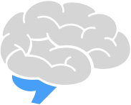 | SENSORY STRATEGIES  The language of the brain stem is… sensations.
Horse Lips | Loosen your lips and blow… allow the air to wriggle your lips and do these with a large inhale and even bigger exhale. We can laugh, too, as we calm the brain stem areas where the stress response begins!
Rhythm Circles | Rhythm circles take just a few minutes as the class mimics the leader in claps, snaps, stomps, or drumstick patterns. We use paint sticks from a local hardware store; students can decorate these and keep them all year long! We sometimes use music, sounds, or one another as we follow the lead of the designated drummer or rhythm maker. We can vary this drumming from soft to loud, slow to fast, and even move our bodies as we drum together.
Hand Massage | Once a day or as students walk in, pass out a drop of lotion, and for 90 seconds students give their hands and fingers a massage, noticing their palms, joints, fingertips, and any sensations that feel uncomfortable or stiff. Allow students to choose scented or unscented lotion.
The 7/11 Breath | Inhale for 7 seconds & exhale for 11.
Sensation Word Drawing | This is a great way of using imagery and art to activate the right hemisphere while integrating both hemispheres for cognition. Students choose a sensation word and draw an image of this word using size, shape and color, and possibly where they feel it on their bodies (tired, numb, tense, full, fuzzy, soft, open, flowing, teary, edgy, tight, etc.).
Hot Chocolate Breath | Imagine you are holding a cup of hot chocolate, feel the warmth of the mug in your hands, take a deep breath in, and then slowly blow out your exhale as if you are cooling down your hot chocolate.
Bi-Lateral Scribbling | - With two markers, begin scribbling vertically and then horizontally each for 15 seconds.  - Take a marker in each hand, make two arcs at the same time across the page, and continue until there are several forming a rainbow shape.  - Begin to make circles, with each circle becoming smaller until those turn into dots on the page.  - Tracing paper is great for students to begin tracing their favorite objects and drawing around the perimeter of shapes.
Whack the Balloon | Foster eye-hand coordination by sitting across the table from the child with a 12-inch balloon as the child holds a heavy cardboard tube about 1 inch in diameter. Move the balloon back and forth very slowly about 2 inches off the table and then pick up speed as the child tries to hit the balloon.
Drumming | Drum to different beats such as a piece of instrumental music, a song, or a metronome, drumming a pattern and mimicking the pattern back. Drum on your laps, with cups, with small drums, etc.
Temperature Sensations | Try using a change in temperature to regulate:  - Ice chips  - Heating pad  - Cool fan  - Hand and toe warmers  - Icy-hot
Draw the Beat | Children can listen to the beat of a piece of music and, with crayons, draw how they visualize and imagine the beat using colors, shapes and different sizes.
Emotional Freedom Techniques (EFT) or Tapping | 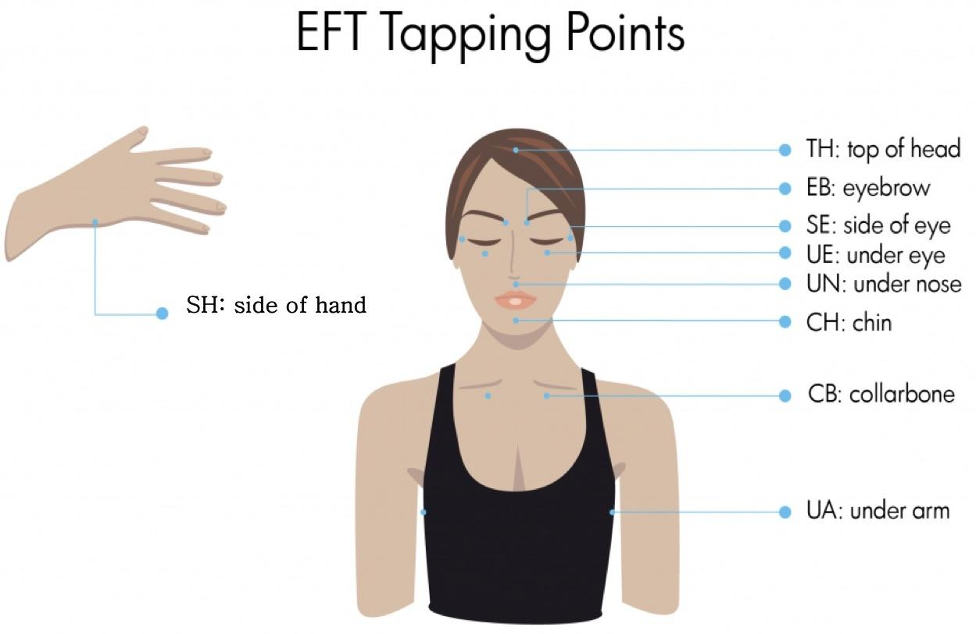  Gently tap on acupoints on the body. You can pair this tapping with positive affirmations said aloud or whispered.
Wake Up the Singing Bowl | Students listen to the sound that the bowl creates while collectively placing their fingers on their vocal chords and trying to match the singing bowl’s tone. Follow this with three deep breaths, and then take turns waking up the bowl, matching the sound while increasing your breaths to five or six long inhales and exhales. Also, students can close their eyes and listen to the tone until it fades beyond their hearing. When this happens, have them raise their hands in the air. Some children may be sensitive to these sounds, so pay close attention to each child’s response and adjust this activity as needed.
Taking a Sensory Bath | Gather a group of three or four children into an area of the room with a large beach towel, a bath-time luffa, a tube of lotion, and plenty of smiles and curiosity. Students can choose to take their own luffa and press it on their arms and legs pretending to scrub and clean; or they can choose an adult to give them the sensory bath.  Model this activity as you begin by pretending to step into a warm, sudsy tub. Have everyone sit down together and sing in rhythm, “We’re taking a brain bath, a brain bath, a brain bath, we’re taking a brain bath to help us feel________!”  Have students choose different words to fill in a sensation or feeling (happy, bubbly, fresh, clean, peaceful, etc.). Once everyone has patted the luffa up and down their arms and legs and on top of their heads, pretend to carefully step out of the tub. One at a time, wrap up each child tightly in the oversized beach towel while swaying and rocking back and forth, continuing to sing. This time, sing about drying off and feeling ready for the day. Students can then select a drop of hand lotion to massage on their hands, leaving the area with three deep breaths as they enter into their day of learning.
Ultra-Natural Pain Relief Gel | When we place a drop of pain relief gel in an area on our body that feels tense, anxious, tight, or uncomfortable, we teach our students how to pay attention to one particular spot and notice sensations. This is a great way to prime the brain for attention as we hold a quiet time for about 2 minutes while students place a drop on their hands, arms, neck, or shoulders, smell the aroma, and feel the texture. These 2 minutes integrate the senses, bring us to the present moment, and rejuvenate our frontal lobes so they are ready to learn!
Trauma and Tension Releasing Exercises (TRE) | Trauma and Tension Releasing Exercises (TRE) are intended to release pent-up stress and anxiety in the body. These exercises stimulate the body’s innate tremor mechanism and target the psoas muscles, which are our fight-flight muscles in the pelvic region. Children’s nervous systems are still developing, and these exercises are gentle enough to produce a bit of contraction and then release, allowing the child or adolescent to feel the sensations in their bodies.  Fast = Charge. Fast movements activate the nervous system, producing possibly pent up energy.  Slow = Recovery. Lower, more intentional movements slow down our nervous system, activating a parasympathetic response.  Contracting and Stretching  - We crunch and release our toes 5 times; then we rotate our ankles.  - Standing, we rise up on our toes 5-10 times and then release. Recovery is sitting down and shaking out the calves.  - We work our quads and hamstrings with a chair pose. We squat 5-10 times and then stretch by pulling our leg behind us.  - We can place a ball between our legs, squeeze it tight, and then release to produce a charge and release.
TRE Foot Rolls | Spread your feet slightly wider apart than your shoulders and point them forward. Roll onto the sides of your feet rolling them in the same direction. You should be on the outside of one foot and on the inside of the other foot. Hold this position for a few seconds, then sway the body in the opposite direction and invert your feet. Continue swaying very slowly back and forth like this, 5-8 times in each direction. To end the exercise, shake out your feet.
TRE Tiptoe Raises | Place one foot in front of you and put all your weight onto the front leg. The back leg is on the floor just for balance. With the front standing foot, come up and down onto your toes, raising your heel as high as possible, then lower your foot to the floor. Repeat coming up onto your toes and back down about 5-8 times, depending on the strength and flexibility of your legs. If it becomes painful or begins to produce a burning sensation, stop the exercise! Come to a standing position on both legs and vigorously shake the leg you just exercised to eliminate any pain, burning, or discomfort. Repeat this same exercise with the other foot. When finished, vigorously shake the leg to relax the muscles.
TRE Hip Stretches | Keep your feet in the same position as the previous exercise. Place your hands partly on the lower back and the buttocks to support the lower back. Slowly push your pelvis slightly forward so that there is a gentle bow in your lower back. You should feel a stretch at the front of your thigh. This exercise is not about arching the back, but about pushing the pelvis forward so that the back naturally arches. This should be a gentle stretch according to your body’s ability. Gently twist at the hips to keep the bowed position, looking behind you in one direction. Take three deep breaths. Turn again from the hips in the opposite direction, keeping the bowed position while looking behind you. Take three deep breaths. Return to facing forward, keeping the bowed position while taking three more deep breaths. To finish, release the bow and come to a normal standing position.
Peaceful Brushing | Using a variety of makeup brushes, model peaceful brushing as you circle your face and ears. Then brush your arms, hands, and palms. Let students choose whether they want to brush themselves or want an adult to brush them, and then have them take turns brushing faces, necks, arms, and hands. This light touch is stimulating in a gentle way, and students can brush their own peaceful spots.
Regulate With Another | Choose and partner. Without talking, find a rhythm in your own breathing with your partner. Change it up!
Vocal Cord Vibrations | Having everyone place fingers on their throats, the teacher begins the day with a sound, and then the students mimic the sound while feeling the vibration of their vocal cords. This gives everyone a chance to discover how different voice tones and volumes feel in the body. Students can also try mimicking different animals, instruments, and random classroom sounds such as papers crinkling.
Lotus Flower Breath | Place the fingertips of both hands together. With an inhale, pull your thumbs apart and bring them together on the exhale. Go through each finger with the same inhale, pulling the pair of fingers apart and then exhaling the fingers together. On the last breath, pull all apart on the inhale, and then exhale your fingertips back together, fingers apart. Keep the heels of your hands together on this final breath, as if you're opening a flower.
Metronome Rhythms | - Draw to the beat of a metronome.  - Clap, snap, or drum in time.  - Exercise to the beat of a metronome. Try animal walks or moving your arms as you speed it up or slow it down.
Start With Art | Begin the day or period with 90 seconds of art and writing. Have students draw and paint with their eyes closed (if they choose) to bring their attention back to the present moment! Other than the 90-second count, there are no rules or guidelines for this activity.
Yoga Movements and Holding Postures | Yoga movements and holding yoga postures increase endorphins. Warrior is excellent, as are seated postures with twisting, and standing postures where we can see our environments. (Be aware that some postures can trigger feelings of trauma.)
Roller Coaster Ride Through Space | In this focused attention practice, we stand up with our feet shoulder-width apart, and bring our arms up to shoulder height, bending at our elbows. Standing like a scarecrow, we begin slowly twisting our upper body to the left and to the right, gradually picking up speed with our eyes closed. Our feet and legs do not move. As we move back and forth, we deeply inhale and exhale with each breath!
Parasympathetic Breathing | Initiate your parasympathetic nervous system by inhaling through the nose for 4 counts, and exhaling through the mouth with lips pursed for 8 counts.
Focused Sound Breathing | Focus on a sound as you slow your breathing, gently inhaling and slowly exhaling.
Spine Rocking | Have students rock along their spine to help them feel present in their bodies. This also provides a soothing rhythm that subtly grounds them with sensation and movement.
Feeling Your Breath | Place your fingers just an inch or two in front of your mouth. As you breathe in through your nose, inhale a shallow breath and feel the air, then exhale through your mouth. Now breathe in through your nose and exhale through your mouth as you blow up your belly with a deep diaphragm breath. Feel how much warmer this air is against your fingers.
Belly Breathing | Place one hand on your belly and one hand on your chest. Breathe in and out normally, noticing which hand rises and falls. How do you normally breathe, deep or shallow?
Tongue Talking | Loosely place your tongue on the roof of your mouth and begin to speak without moving your tongue from this position. Create a class chant to say together. Since this can be an awkward exercise, the teacher should be prepared to go first, modeling the activity and breaking the ice!
Body Scan | Have students sit with their legs straight out and begin wiggling their toes and ankles, shaking knees and thighs, rotating shoulders, arms, and finally their heads, keeping all body parts moving at the same time. Then reverse the process and stop moving heads, arms, shoulders, and on down. This sequence also promotes working memory.
Drawing Emotions | Draw what happiness looks like! Draw what sadness is! Draw how anger feels and what it is! Now look at your art, then close your eyes and feel in your body if happiness, anger, or sadness are there. Where in your body are those feelings located?
Finger Raises | Inhale and lift the forefinger of your left hand, then lower this finger as you exhale. Go through these breathing movements raising and lowering each finger on both hands. You can use other parts of your body to match the inhale and exhale with 10 deep breaths, always exhaling a bit longer than the inhale.
Humming | There are so many ways to incorporate humming during a brain interval or at the beginning of the day! You could initiate a Simon Says, mimic me, name that tune, or move your arms and legs to the humming. This activity releases stress and blockages in the brain stem, flooding our systems with a norepinephrine release!
Scarf Dancing | Putting on music, give students old scarves and dance around the room together, waving the scarves and feeling the soft sensation as you dance and pass by one another. When the music stops, freeze. Notice your postures and the movement you interrupted by freezing. This strategy can be led by the teacher or a student to demonstrate that everyone can mimic a movement or create their own.
Double Scribble | With a different-colored marker in each hand, draw or scribble to the beat of the music for 30 seconds. When you finish, see if your drawing turned into anything familiar or strange. Share with a classmate and then give each other's drawing a name!
Stretch & Hold | Do some light stretching. Try holding a stretch while you breathe deeply.
Hold Your Cheeks | Place both hands on your cheeks. What do you notice? What do you feel?
Walking Labyrinth | Create a walking labyrinth using colorful tape. Students can then try to walk backwards or crawl. Add balancing a bag of rice or beans to make it even more challenging.
Funny Voices | Talk in a funny voice for 30 seconds. This voice could be deep, high, slow, drawn out, laughing, interspersed with hiccups, or anything else you can imagine. Let the students decide!
Kind Pressure | - Give yourself a bear hug.  - Give yourself an arm or leg massage using gentle squeezes.  - Give yourself a gentle neck massage.
Mannequin Freeze Challenge | Challenge students to hold a mannequin’s pose, staying as still as they can. Gradually increase the length of time for holding these poses.
Lava Bottles | Have students create their own lava bottles to focus on while they breathe. You can find instructions here: https://awakeandmindful.com/how-to-make-diy-meditation-jar/
Brain Freeze | Stop with a sound! Ask students to show you how they might suddenly freeze, melt, moonwalk, or disappear.
Writing Switch-Up | Write your favorite word with your dominant hand four times, and then write it again with your other hand. How did it feel? Which hand was more difficult? Why? What happened in your brain when you wrote with your non-dominant hand? What would help your non-dominant hand to become stronger?
Rectangle Breathing | Trace a rectangle with your finger, inhaling as you trace the short side and exhaling as you trace the long side.  Inhale  Exhale  Inhale  Exhale
Create Heat | Rub both hands together as fast as you can until they feel hot. Then release.
Resistance & Tension | Create resistance and tension by having students do wall push-ups and squats.
Guess the Sound | Have students close their eyes for 30 seconds, mindfully listening to all the sounds they can hear in that time. Then students can share the sounds they captured.
Regulated Pacing | Create a pacing strip for students to use individually within the classroom. Many students feel calmer and more regulated when moving, and a strip of duct tape in a designated area of the room can be their pacing path to learning!
Tongue Stretch | With clean hands or a Kleenex, stick out your tongue and stretch it as far as it can go! This relaxes the throat, palate, upper neck, and brain stem. What could you add to make this exercise funny?
Track the Rhythm of Your Heart | Make pulse oximeters available in the classroom so that students can locate a resting heart rate, and then note and track the changes in their heart rates during the day. Name the sensations and feelings you experience in our bodies as your pulse rate rises and falls.
Mini Obstacle Course | Create a miniature obstacle course using a step stool, hula hoops, and other materials.
Building Regulation | Students can regulate through repetitive, patterned work. When we build and create with Legos, blocks, cards, magnetic shapes, or other objects, we find a rhythm to our activity as we repeatedly choose an object, balance, observe, add to... until we finish and admire our creation!
Animal Walking | Have students do a crab walk or slithering snake.
Walk the Tightrope | Practice toe and heel walking along a designated line that we draw or create. We alternate walking the line on our toes and then on our heels, possibly moving back and forth with a heel toe movement every other step.
Safe Place Visualization | Walk your students to their “safe place.” Have them close their eyes and with soft music playing in the background, and verbally take them on a journey to their own special place. In this focused attention exercise, they imagine colors, sounds, tastes, people, activities, places and sensations! When they return from their “safe place” trip, reflect on your journeys! How did it feel? What was the best part? Who was with them? What did they see? What did they hear?
Invisible Jump Rope | Divide students into groups of 3. For 9 seconds, jump with an invisible jump rope. Students will take turns holding each end of the rope and jumping for equal amounts of time. Have fun with different jumps and combinations. Make sure those holding the rope are in sync with one another. Afterward, reflect on how this felt by writing down your jumps, the sequences of jumps, and if this exercise could really improve how you jump with a real rope! Why or why not?
Drawing Your Breath | Take a moment and notice how you breathe. Do you notice a rhythm? A pattern? A pace? Try to draw your breathing.
Regulating Sound | Sometimes it’s helpful to provide background noise. White noise is regulating for some children and adults as it is a subtle, unwavering sound that can calm us while we work, play or sleep. Try using a noise machine or water element.
Calming Weight | The use of different weights can be regulating--and grounding as well. Have students carry weighted objects or do some heavy lifting. Add small weights to your Amygdala Reset Area.
Wriggle & Shake | Wriggle and shake out your tension, adding one body part at a time.
Textures | Different textures can be soothing to the brain stem, such as a weighted lap pad or blanket, soft yarn balls, or scented blankets.
Dancing Breaks | Incorporate dancing breaks throughout the day. You can even try chair dancing!
Eye Yoga | Take your right first finger and place it 12 inches in front of your nose. Without moving your head, follow the movement of your finger with your eyes--left, right, up, and down. The only part of your body moving is your eye and first finger.
Blowing the Trumpet Breath | Take a deep inhale and then slowly exhale through your mouth, holding your hands as if blowing a trumpet, vibrating your lips until the end of the exhale.
Squishy Pillow Sandwich | This requires two large pillows. Laying one pillow on the floor, the child lies across the pillow on their tummy. Ask “What would you like on your squishy sandwich?” Use your hands to spread or sprinkle the requested ingredients with generalized touch and pressure along their back. Then lay the second pillow on the child’s back, pressing gently to create the most delicious mushy sandwich!
Toothpaste Squeeze | The child lies on their stomach. Roll a large exercise ball from the child’s feet all the way up to their head. As you roll the ball along the child's backside, narrate how you are very slowly squeezing the toothpaste out of the tube!
Vacuum Cleaner | Children lie on their backs with their arms behind their heads. The adult gently grabs their ankles swaying them back and forth to warm up the vacuum cleaner. Then the adult slowly scoots the child back and forth just as a vacuum moves along the carpet. This is a powerful sensory practice for calming the nervous system.
Sucking & Swallowing | The act of sucking and swallowing triggers a regulatory response of stimulating nerves connected to the parasympathetic nervous system. Use any of these methods:  - Drinking warm water  - Dum-Dum suckers  - Ice pops in paper cups, frozen grapes, or fruit juice  - Sucking yogurt through a straw  - Water bottles with straws or sippy cup lids
Chewing to Regulate | Rhythmic chewing helps to regulate the reticular activating system (RAS) in the brainstem. Crunchy foods in particular produce a stimulating reaction that enhances attention and alertness. Suggested strategies include:  - Chewing gum  - Crunching on Cheerios or crackers  - Eating a chewy bagel
Regulating Essential Needs | Offering students a drink of water and a small snack helps to regulate their nervous systems. The brain cannot think straight when it is hungry or thirsty!
Clothespin Drop | Standing above a jar, try to drop clothespins into the jar without bending over. Add an extra challenge by raising your arms upward.
Sensory Discrimination | Sensory discrimination helps focus attention and creates associations that students can identify and therefore understand. We help children compare and contrast the way things look, feel, hear, and move!  - Use visual discrimination techniques with white on black scribbling or drawing.  - Promote tactile discrimination by having students feel different objects to see what they are.
Lavender Yarn Balls | Taking thick balls or skeins of yarn, show students how to wind these into balls. Then dab each yarn ball in a little lavender.
Blowing and Popping Bubbles | Sit in a circle. Using bubble fluid and a ring, take a deep breath and blow bubbles with a long, slow exhale, watching each one until it lands and pops. This strategy attends to breath, attention, and focus. Have children sit on their hands and pop the bubbles only with their eyes. This can be difficult, but by having them watch and not use their fingers, this strategy helps them create a pause, learning how to hesitate without immediately reacting!
Taco Roll | The taco roll is implemented for body awareness, rhythm, and some gentle but firm pressure. Children lie down on a blanket, and an adult slowly rolls them up, winding the blanket around them with a gentle pressure. When they're ready, unroll them with a little speed as they pretend to roll down a hill. This is also an excellent (and fun!) strategy for vestibular integration (balance information provided by the peripheral sensory organs).
Cloud Surfing | This is an exercise in body awareness, imagination, calming, and regulating through the sense of smell. Sit on beach towels and give each child a lavender-scented cotton ball representing a cloud. Talk about the sky and clouds, and imagine flying through them while smelling the cotton balls and moving your bodies to mimic flying and soaring. Then share what you saw below.
Car Routine | This is an alerting strategy to prepare bodies and brains for the day! Begin this activity by sitting on the floor with legs stretched out. Start up your engines by wriggling legs and arms. As soon as your cars are warmed up, take off down the highway. Have students stand and follow the leader. We did this with our little animal buddies as our passengers, attached to the children’s shoes to help them pay attention and focus, moving deliberately and carefully so their buddies would “stay in the car.” This strategy attends to body awareness, focused attention, gross motor movement, balance, and motor and emotional regulation.
Roll Exercise Ball - Bounce On It - Repeat | Have children roll a huge exercise ball along a path and then stop, freeze, jump on it, and circle back around.
Merry-Go-Round | As a vestibular exercise for balance, have children stand and spread feet apart while holding out scarves in front of them. Have them move their upper body from side to side, either watching the scarves dancing in the air or closing their eyes.
Rock and Roll | For gross motor and vestibular activation, roll back and forth on your back, looking up to the sky and noticing everything around you! This is an exercise in core strength and rhythm activation, as many of our children have weakened or underdeveloped core strength.
Flying Swings | Take off running as if swinging high in the air. Then freeze for a few seconds while taking 3 deep breaths. Repeat these movements three times! This strategy focuses on attention, gross motor, breath, and movement.
Rocking Hammock | Double up a soft blanket. Children take turns lying lengthwise on the blanket. Others pick up the ends and gently swing the blanket back and forth, singing together a made up song using the child's name. Gradually decrease the swinging motion to smaller movements and then slowly bump, bump, bump to the ground!
Amygdala Reset Areas | Create an Amygdala Reset Area with some of the following items:  - Balance board (kinesthetics, balance, movement)  - Exercise (or yoga) ball (kinesthetics, balance)  - Yoga mats (Trauma and Tension Releasing Exercises [TRE]/yoga) (kinesthetics, balance)  - Constellation night light (visual, focused attention)  - Liquid motion timers (visual)  - Wood labyrinth table maze (movement, focused attention)  - Hoberman Mini Sphere (breathing, focused attention)  - Glitter wand (visual, focused attention)  - DNA Stress Balls (tactile, squeeze-release, TRE)  - Stacking cups (kinesthetic)  - Rain stick (auditory/tactile)  - Your Fantastic Elastic Brain book (neuroanatomy)  - My First Book About the Brain (neuroanatomy)  - My Little Brain book (neuroanatomy)  - Rosie’s Brain book (neuroanatomy)  - Coloring books, crayons, colored pencils (tactile, visual)  - Bubbles (breath, visual, tactile)  - Play-doh (tactile, visual, olfactory)  - Relaxation music on a CD/MP3 player (auditory)  - Hand lotion (tactile, olfactory)  - Puzzles (visual, tactile)  - Motivational posters (visual)  - White board (visual)  - Water (hydration, gustatory)  - Snack crackers (Nutritive, gustatory)  - Gummi Bears or bubble gum (kinesthetic, gustatory, rhythmic chewing)  - Jump rope (kinesthetic)  - Essential oils (olfactory)

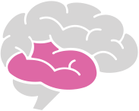 | Connection Strategies:  The language of the limbic system is… feelings.
2 by 10 | For 2 minutes each day, 10 days in a row, teachers have a personal conversation with the student about anything the student is interested in (as long as the conversation is G-rated). Also try 1 by 30 and gradual release.
Catch Me! | “Catch” students doing or saying something kind! Notes of gratitude, messages of noticing, and stickers contribute to students’ feelings of purpose and connection. This strategy can be used by teachers, aids, bus drivers, custodians, office staff, administration, etc.
Caring for Your Buddy | Take care of a staff member or another student through a Post-it, a smile, a question, or a talisman.
Partner Heart Rates | Measure your heart rate. Monitor and share with a partner.
Monster Drawing | With a partner, silently create a silly monster in one minute! Take turns adding to each other's drawing with shapes, lines and colors for one minute.
Newsletter/Website/  Social Media | Create a classroom newsletter, website, or a social media account for sharing with parents to recognize the familial tribe of connection these students and this teacher have together! This could also be done in other communities such as a bus, a specials class, or an after-school group.
Noticing & Noticing Sheets | 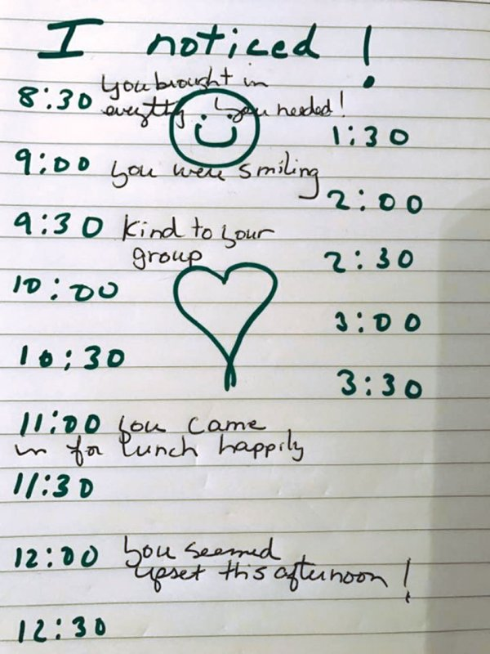  Noticing:  - New shoes  - Haircut  - How a student walked into class  - A smile  - A gesture  Noticing Sheets:  With older students, this noticing can be reciprocal with ground rules. (If you're noticing details, behaviors, and moods about your students, they can notice something about you, too!) Students love homemade worksheets from their teachers. Even during an off day with many challenges, we can always notice very specific behaviors, moods, or actions! This also allows us to track patterns of behaviors. It's a very simple yet effective daily activity! Even with 30 students, we can always jot down a quick note or even a "thank you!" when we see a positive.
Journal | Try journaling with a personal diary at the beginning of a class period or day. Writing can be in the form of pictures or any type of art that feels good to express.
Take Your Order | 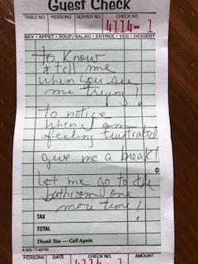  Take Your Order  - What do you need today?  - A break?  - Your favorite snack?  - Time to meet with another educator?  - A visit to another school?  - Time to yourself ?  - An affirmation?  - Supplies?  - An ear and a heart that will listen?
Touch Point Check-ins | Each morning and afternoon, students can check in with a chosen adult to share how they are feeling through a thumbs up, thumbs down, or neutral show of emotion. This is a great way for adults to notice patterns while students create a connection of trust! This strategy can be used by teachers, aids, bus drivers, custodians, office staff, administration, etc.
Safe & Calm Communities | Create a sense of safety and calm community by playing calming music, using call and response songs or chants, and creating a display of special projects or VIP work to recognize and accumulate successes. These strategies could take place in a classroom, on the bus, in after- or before-school care, in the cafeteria, etc.
Positive Referral Sheet | 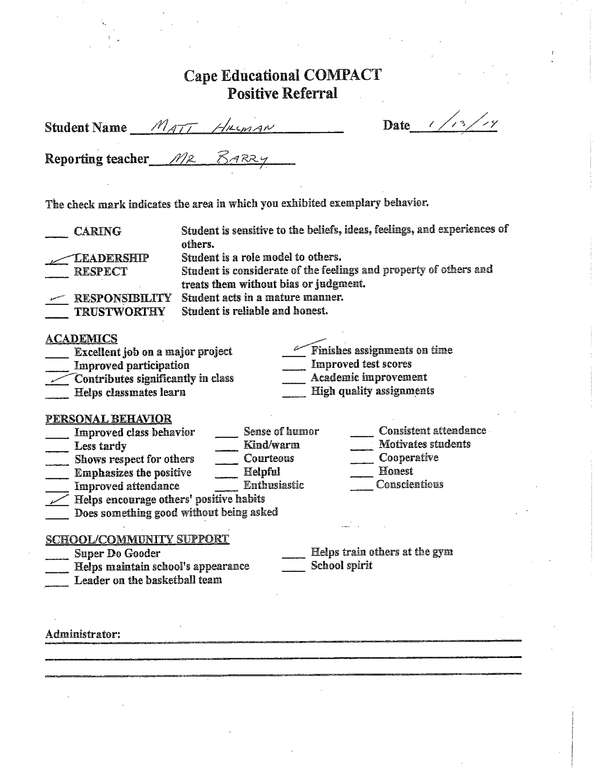
Active Constructive Responding | This process means stepping into experiences with another person and responding with questions, details, and interest. It is a form of questioning that asks and focuses on details when another individual shares something about an experience, event, idea, or relationship.  - Where were you when you saw this or heard this?  - Who was with you?  - What were you doing right before this happened?  - What were you doing when this happened?  - What did it look like?  - What sounds did you hear?  - What was their reaction?  - What else did you notice?  - How did this feel?  - Now, how will this change things for you?
Power of Questions | This process offers two points for regulating and modulating feelings and emotions: in the moment and later.  In the moment:  - What do you need?  - How can I help?  - What can we do to make this better?  - Is there anything you need right now that would ease your mind and your feelings?  - Is there another way you would like to talk about this other than words? I have paper, pens, crayons, and clay, or you could paint a picture.  - If you could list three or four people that you need right now, who would they be?  - Is there a place you would like to rest where you can feel safe until you feel a little bit better?  - Are there any objects or belongings I can find that would comfort you?  Later (once regulated):  - What are your resources?  - What feels difficult?  - What could be the best possible outcome?  - What is the worst thing that could happen?  - What is the first step in improving this situation?
Validation | When we validate a student, we rephrase the content of what they are saying, and we label the feeling behind the words we hear.  - That must have made you feel really angry.  - What a frustrating situation to be in!  - It must make you feel angry to have someone do that.  - Wow, how hard that must be.  - That stinks!  - That’s messed up!  - How frustrating!  - Yeah, I can see how that might make you feel really sad.  - Boy, you must be angry.  - What a horrible feeling.  - What a tough spot.  - That must be really discouraging.  - I bet you feel disappointed.  - Yikes, I know how much that meant to you.  - Tell me more. (This response shows interest.)  - Wow, he/she must have made you really angry.
Emotional & Academic Designer | This brain-aligned strategy taps into the student’s interests, passions, and expertise. These techniques are implemented for students in a frozen stress response state to free up some of the negative emotions of helplessness and hopelessness. This brain-aligned strategy is process-oriented and builds over a one-, two-, or six-week time period. Many students walk into classrooms with a “shut-down” response which produces little to no homework or assignment completion and engagement. These students are often referred to as internalizers. Their deep-seated anger and fear can look defensive, withdrawn, helpless, and disengaged.  At a neutral time, we suggest a variety of ways to complete small chunks of assignments. These might include drawing, painting, sketching, voice recording, video making, or any other medium of the child or adolescent’s choice. Chunking refers to shortening assignments so that completion feels possible and doable. Often, I've actually been the scribe who takes notes as the student speaks their thoughts. We begin with short, concise assignments that students feel comfortable in completing. We compromise and ask for their input, questions, and thoughts, and we agree to check in with one another during this process. The check-in isn't for evaluation or assessment, but instead for mutual feedback and dialogue. This strategy could also be implemented for a resiliency touch point.
Have a Cup of Coffee | Personal coffee cups for all students could be filled with water, hot chocolate, tea, or juice throughout the week. As the class shares a cup of coffee, we also share appreciation, apologies, and "aha!" moments. We can also take this time for our role and responsibility leaders to share what they have noticed. This is a great time for touch points! We can begin to incorporate Monday Brunch, Wednesday Game Day, and Friday Movie Afternoon. When we feel felt and with a sense of purpose, we begin to flourish. Discuss these questions:  - Am I important to someone here?  - Can I share my gifts with someone here?  - Can I serve someone here?  - How do I feel here most days?
Connection Buckets | At the front of the classroom/bus, there could be three buckets, each with a different label: 1) “What do you need today? Reach in and grab a pick-me-up!” 2) “What’s on your mind? Let’s work it out together!” 3) “Celebrations!” Each day, a student can reach for an affirmation, a book, a Sudoku, word search, coloring book, a cotton ball with lavender, some hand lotion, or other calming items. A “Celebrations!” bucket would be a wonderful way to incorporate daily or weekly successes, letting students take a leadership role announcing all the celebrations of students in their classroom (or on their bus) on a Friday afternoon!
Animal Totems | Have students choose an animal and invite them to draw, sculpt, create, etc. something to represent their animal. Ask them:  - What's one animal that you relate to, think about, or would like to have? Maybe it's an animal you don't like.  - How are you similar to this animal?  - How are you different?  - What strengths does this animal have? What weaknesses?  - What would this animal’s home look and feel like?  - What superpowers would you give this animal?
Kindness Letters | Write a letter to someone who has been especially kind. This could be once a day, once a week, or whenever the time feels right. It doesn’t have to be a fully written letter, just a few sentences that can be shared after they are written. Nothing moves us toward positive emotion more swiftly and steadily than gratitude!
The Load I Carry | Paint or draw the “load you are carrying.”
Painting With Imagery | This strategy can be a whole-class or one-on-one activity (we've used it both in morning meetings and as bell work). Using a symbol, image, or metaphor, paint lines, forms, shapes, and colors. We ask students to fill up the paper with paint. If a student describes their paper as messy, confusing, strange, and weird, we use those words to create questions for the student.  - Do you ever feel confused, messy, or weird?  - Can you paint the word confused?  We can always help the student repair and heal an image they created but don’t like! This too is a part of co-regulation.
The Things I Carry | In the front of the room is a backpack filled with five or six items, pictures, or words that I identify with or hold close to my mind and heart. As I model for my students the contents of my own backpack, I begin to share who I am as a person and not just an educator. This is a powerful way for not only getting to know your students, but also tying in the contents of the backpack with a class novel, science experiment, or any standard you are teaching by aligning these items to what students need to know! Students can guess what items might be in the backpack before they're revealed. Prediction is an effective brain state that increases the dopamine levels responsible for pleasure and goal- seeking behaviors.
Belief Systems | Understand that a belief system for a student with significant trauma and adversity might be filled with unlovable, shameful, and unworthy thoughts and feelings. To regulate, we have to give that student some space and time. Then, before giving a consequence, we need to validate the student's feelings. Our belief systems are our realities! Here is an example:  - Teacher: "Jonah, I know this is going to be hard, but you're not able to go out to recess today because of what happened earlier."  - Student: "That's not fair!"  - Teacher: "I know this cannot feel good to you!"  - Student: "But it wasn't my fault!"  - Teacher: "Why don't you and I sit over here and talk more about this so I can better understand your point of view."
Reflection Questions for Our Most Vulnerable Students | Questions to ask ourselves with our most vulnerable students:  - What else is going on here?  - What does this child need?  - What keeps me looking only at the behavior and not at the child?  - What is this behavior communicating right now?  - What in the environment could be triggering this behavior?
Pockets of Brilliance | Neuropsychologist Dr. Ronald Federici states that many children and adolescents from adversity have "Pockets of Brilliance" because they've had to survive. Find their strengths in these areas. For example, if a student tells lies, how could we turn lying into strength? Understanding that lying is about self-preservation is the first step!!
Color Emotions | Have students fill their papers with colors.  Then ask:  - What color is the largest? If it had a voice, what would it say?  - What color is the smallest? What might that color say?  - What advice would the large color give the smaller color?  - What color is in charge?  - What color would you like to hide? Where would it go?  - Divide the paper in half. Label one half "Where I have been?" and the other half "Where I am going?" for a fun snapshot of the student's present and future life.
Post-It Worries | Write out worries on Post-it notes.
Outline of Me | Create a life-size cut out of the outline of "you" (each individual student) or “us” (one life-size person to show how we are "one" in the classroom). After cutting out this life size model, color-code different places in the body where we experience feelings, and then draw some coping strategies that would help lessen the negative feelings.
Meet Our Buddies | Give students small stuffed animals to care for and attend to while at school. They can give their buddy a name, care for their buddy throughout the day, and take their buddy with them whatever they do. Discuss what their buddies might need to feel peaceful and calm. Many children will project their own lives onto their buddies, providing adults with a source of effective perceptual data.

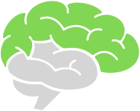 | Cortical Strategies:  The language of the cortex is… words.
Talking to Ourselves | Talking to ourselves can be very calming and helpful when we feel anxious or stuck with a problem or challenge. By talking to ourselves, we're actively reaching out to a friend (ourselves). What you can name, you can tame…
Regulation Routines | Create short routines of 2-3 regulation strategies. These can also be thought of as preventive dosing. Try creating personal prescription pads for dosing and routines:  - Five dragon breaths  - Pacing for one minute while humming your favorite song  - Three rounds of finger tapping
Coping Strategies Wall | Create a wall of experiences that trigger your students and coping strategies to calm them.
Create Brain Maps | What would our map of safety look like? What about our map of experiences that feel scary or fearful?
E-Story | Create an electronic story of personal and school life. In this E-Story, students have the opportunity to let you know who they are through their dreams, goals, and stories. These E-Stories will change much like a time capsule, which is great for reflection, feedback, and relationship building! They will also encourage personal narratives, research, and a free form of creative writing and reading... literacy made fun!
Dopamine Increasing Activities | Write down goals or lists of things you'd like to accomplish in an hour, a morning, or a day. Begin with incremental benchmarks that are doable, and maybe select a partner who will help you with accountability. Create a visual winning streak of accomplishments, processes, or efforts. Seeing is believing!
Classroom Roles & Responsibilities | Choose a classroom role for the week. Click on images below to enlarge or print.  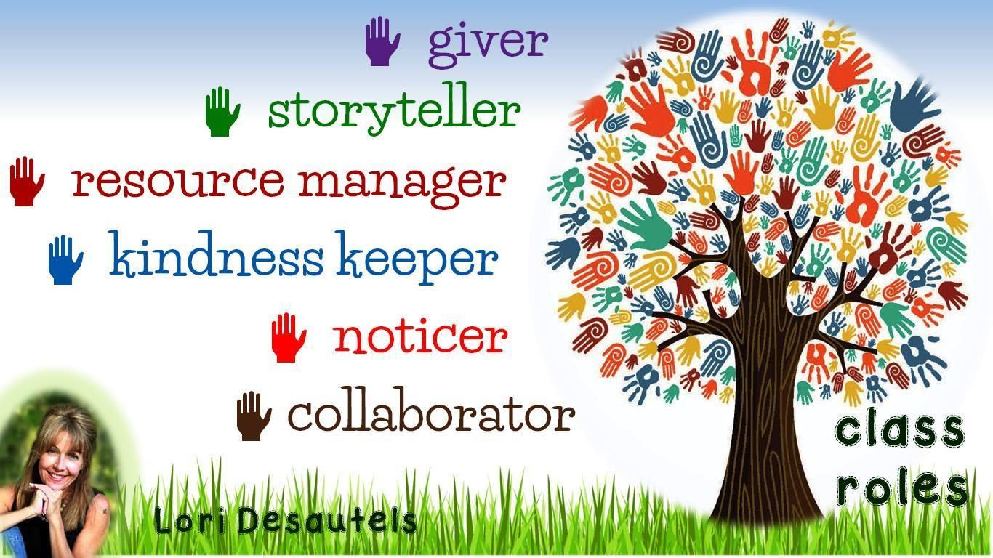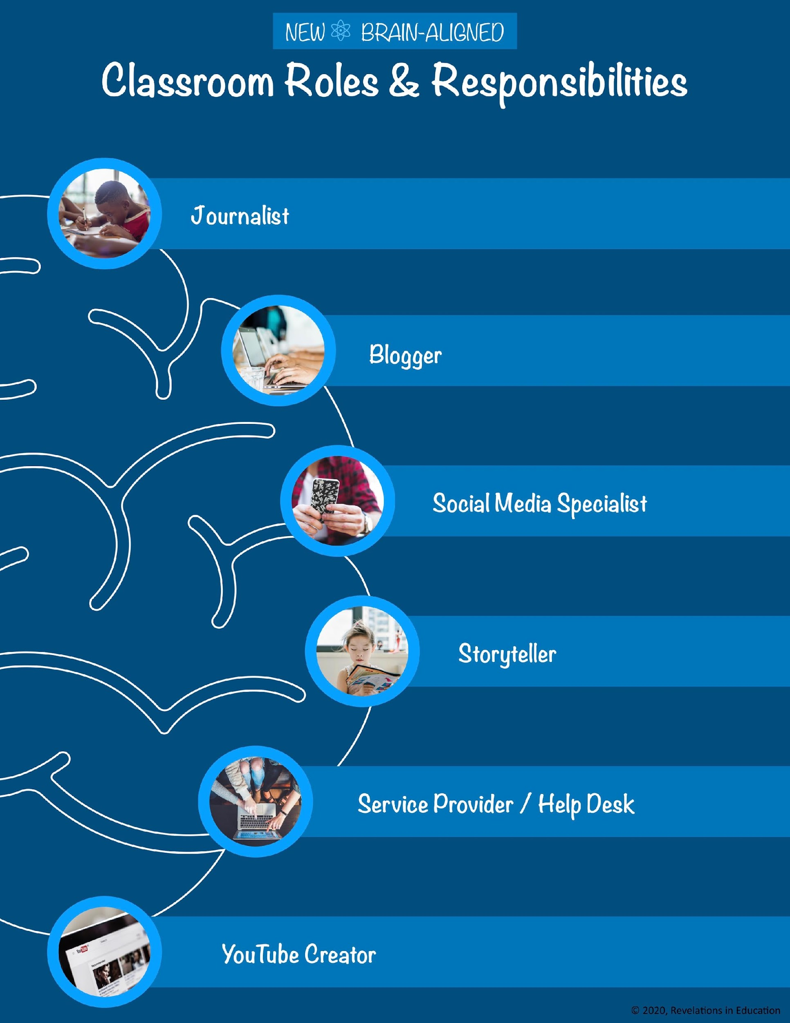
10-Word Story | Write or draw a 10-word story on a specific topic that you're teaching. Or have students write a 10-word story describing their strengths and expertise. Those who don’t want to write could create an infographic.
My Wise Self | Guided imagery is a powerful healing technique. Start with these questions:  - Who is the “Wise Self” soothing, comforting, and accepting you–  or the younger version of you that still lives inside?  - Is this a person? What do they look like? Is this an animal? What would your Wise Self do to calm you and bring you joy? What words of comfort do they share?
Chance to Lead | One of the most effective ways to regulate negative emotion is by providing students with leadership opportunities. Older students could act as mentors for the younger students by modeling focused attention practices (such as how to take deep breaths) or helping them redirect negative emotion through a healthier channel (such as drawing, coloring, or creating a new solution to a problem)!
DIY Commercials | Choose a short TED Talk or documentary and watch the first minute. Following this one-minute presentation, students will predict two or three outcomes as to how this presentation will end. This can relate to the subject matter you've been teaching, or it could be a motivational video that addresses social and emotional skill sets.
The Garden of My Brain | Let’s plant a garden in our classroom and in our brains and watch it grow! Our gardens need water, sunlight, and good soil. They may need shade and a protective fence. Using a journal, which is a touch point, keep track of and share some of the following provocations or pondering questions:  - Who watered you this week?  - Who is your sunlight? Who can see the best and brightest in you when you or others cannot?  - What places help you to feel safe? What people?  - What sounds help you feel safe? What types of rooms or outdoor areas?  - Who protects you? What do you do to self-protect?
Allowing for Choice | Give choices every day with regard to assignments, consequences, homework, and activities? These are choices you can live with as a teacher. Without compromising any higher-level work or negative behaviors, you can empower students with minor everyday choices for things like Do Nows, quantity of materials used, color of paper, using a full or half sheet of paper, doing something before or after a five minute break, etc. There are so many possible ideas!
Brain-Aligned Organic Consequences | What types of consequences will be experiences that can help our students to learn new behaviors?  - Not following directions: Students support creating classroom expectations. When students aren't following, it's time to sit down and have a conversation and connect with students. "What can we both agree to do the next time?"  - Not turning in assignments: Connect. What's making it difficult to turn in assignments? Create a plan together and monitor.  - Disruptive: Provide opportunities to be a classroom leader in positive capacities.  - Disrespectful: Connect. Build a relationship and understand how that student is feeling in class.  - Late/tardy: "How can I help?" Suggestions may include warning bells, more time, early release pass, restroom break at the beginning of class to eliminate stopping during passing and storing materials in the classroom for use.  - Out of seat: Allow students opportunities to move and regulate without punishment. Thank students for taking care of themselves. Provide areas to stand during instruction.  - Doing nothing: Connect. "What do you need? How can I help?" Offer students choices.  - Destruction of property: Give the student time for providing service to the property owner. Have them create videos, posters, and announcements about the importance of caring for property.  - Physical altercations: Use Restorative Justice practices (involving students, families, and teachers).  - Verbal altercations: Use Restorative Justice practices (involving students, families, and teachers).  - Walking out of room: Offer options for breaks, passes for walks, and brain intervals throughout instruction. Ask students when during class they'd like a break.  - Impulse control: Propose regulation activities throughout the learning block, fidgets, mind-wandering time, focused attention practices, and mindfulness exercises.  - Dress code: Identify a trusted adult or a safe space in the building that would provide a change of clothing.  - Procedures: Have students practice or repeat procedures until they learn to follow it.
Escape Stories | These could be written out, drawn as cartoons, or expressed with symbols and words. At some time, we've all had to escape from something or someone that didn’t feel good to us. Maybe your escape story is true or make-believe. Either way, share where you were, what happened, and how you escaped. Do you have a plan for next time? What would you do differently? What was the best part about this plan? Who are the people that could help you escape? After drawing or writing the Escape Story, students could color-code different parts of their scenes with this chart.  - Blue - sad  - Orange lines - nervous  - Yellow polka dots - happy  - Black - feeling numb or frozen  - Purple curvy lines - energetic  - Red - hot and angry or mad  - Brown - tight and tense
Adversity and the New Story | Reframing a negative experience can provide new sensory associations for the child. This could take place in the heat of the moment or in reflecting with a student who has already experienced this adversity but would benefit by telling a new story to reframe the positive aspects, creating new sounds, smells, sights, and tastes for this adversity.  - What were you doing when this happened?  - What did it look like?  - What sounds did you hear?  - Who was with you?  - What was their reaction?  - What else did you notice?  - How did it feel?
Co-Teaching | Every week, students take turns signing up to co-teach with you. They'll help in planning lessons, designing assessments, and doing research! Nothing is more motivating than when students take the lead with their own expertise and build confidence in their abilities to lead, share, and design. In middle school, this might be best to do with partners--peers are everything in these years!
Trees Are Like Our Brains! | Trees are like our brains!  - What do you notice? The tree’s roots are like our nerves.  - What do trees need to grow? What stresses a tree?  - How would your tree look? Does your tree have many branches or just a few? Describe the trunk of your tree.  - Finish with a tree pose!
Ideas for Your Superhero! | Ideas for Your Superhero!  - What is your superpower?  - Where do you live?  - How will your schoolwork change for the better with this superpower?  - What could be different about the brain of a superhero?  - Do you have a secret identity?  - Who is your real-life superhero?  - Do superheroes have neuroplasticity?  - Do superheroes use their amygdala and frontal lobe? How and when?
Belief Commercials | Using images, words, colors, or technology, design an infomercial promoting a strong belief that you hold. This can be a personal belief, one that's developed through recent experience, or a long-held belief that you're now questioning.
Reinventing Gum | Place a piece of Trident gum and five notecards on every desk as students walk in. Have students design five new inventions for chewing gum. They can share and compare at the end of the Bell Work.
Meeting of the Minds | Students will select characters from a book, historical figures, or any author, inventor, scientist, or individual they've been studying. Given a 21st-century challenge, how would these individuals solve it? What would their discussion look like and how would they relate to one another?
Invent a New Language | Either individually or with a partner, create a new language that we need today! This language could be one of feelings, kindness, service, or just a silly language that we make up by adding or deleting words, part of words, vowels, or consonants.
The Traveling Pants | Place an old pair of trousers or blue jeans on a table in the front of the room. Use them to prompt a variety of questions and activities. Where have these pants been? Where would you travel if you wore them? Describe three places you'd travel or goals you'd accomplish with these pants. What will it take for you to get there? How can you begin creating these destinations or goals today?
Writing Blindfolded | Wearing a blindfold or with your opposite hand, write a short review paragraph about a topic that will be on the upcoming test or that needs to be remembered. Following the activity, trade papers with a classmate and see if they can read and understand what was written.
Dream Interviews | When students enter the class, they choose a half sheet of colored paper with a set of instructions displayed on the smart board. In the front of the classroom is an empty chair and maybe some props to create a comfortable setting. The question: “If you could choose any person in the world to spend 15 minutes discussing, questioning, and sharing with, who would this be and why?" The students can write or draw their responses. They have a choice to share responses following the exercise. When I implemented this experience with middle school and undergraduate students, the sharing and empathy in the room was palpable! I learned so much about the emotional and social profiles of these students!
Dual Brain Sheet | 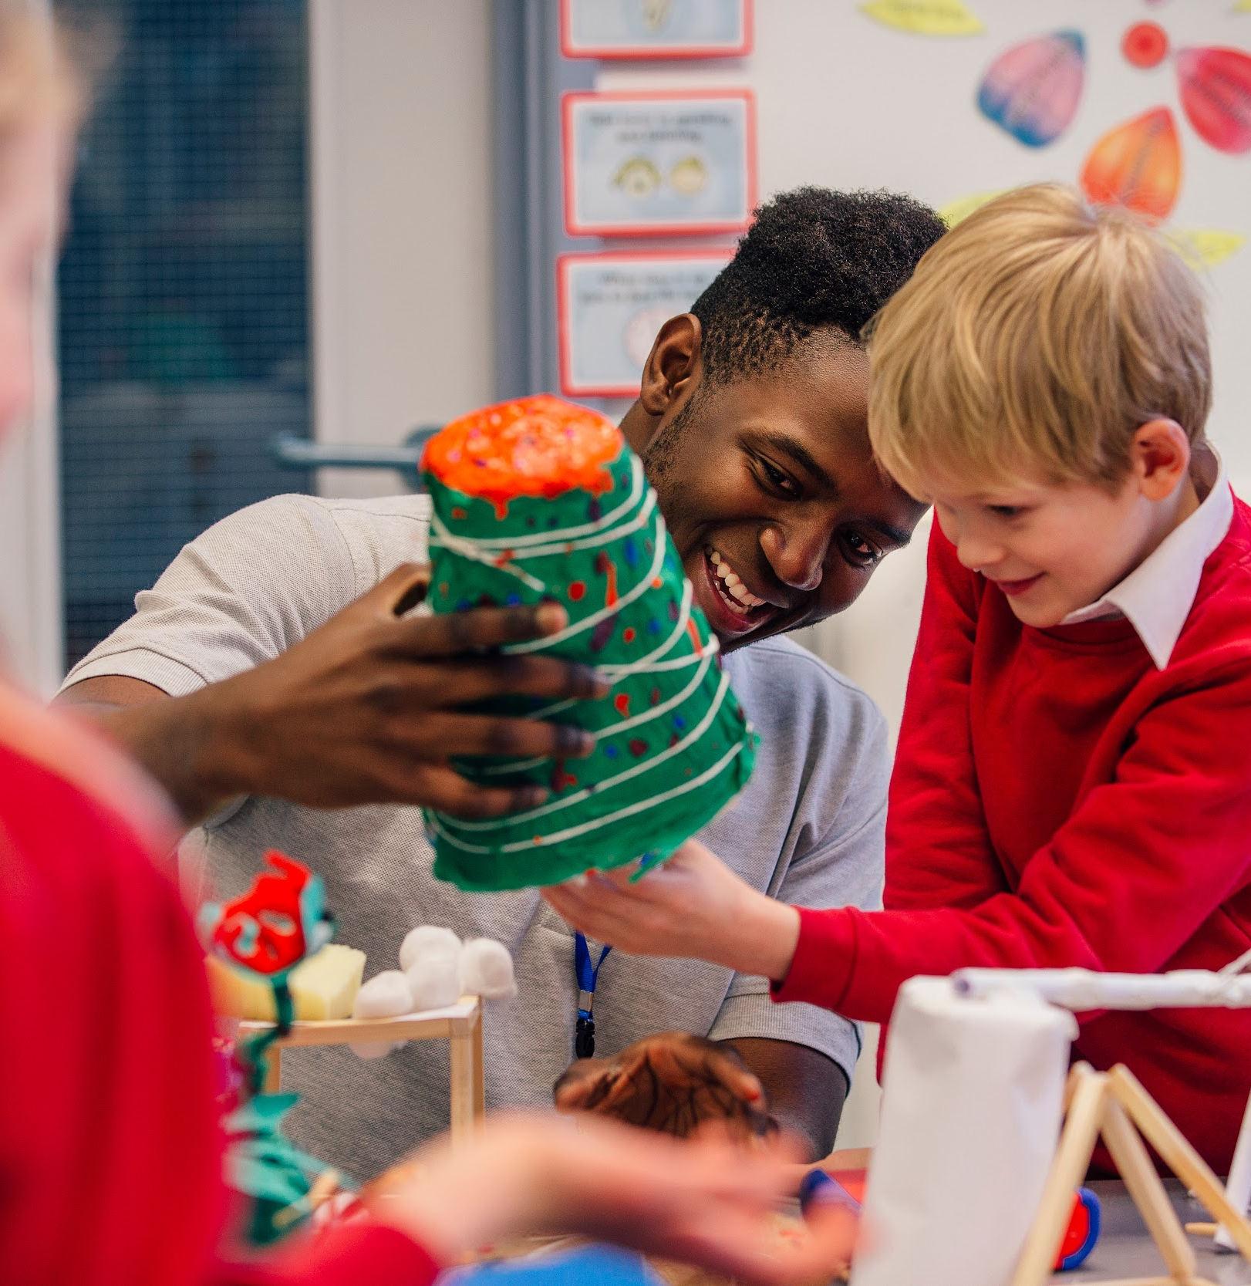  Youth & Adult Working Together  - Youth AND adult will answer questions 1-5 independently.  - Youth AND adult will discuss and then complete 6-10 together.  - Youth AND adult will decide on additional questions to answer.  Youth  - What was our challenge?  - What led up to this challenge?  - How did I handle this?  - Could I have prevented this challenge or problem?  - What are two adjustments that I will make the next time?  Adult  - What was the challenge?  - What led up to this challenge?  - How did I handle this?  - Could I have prevented this challenge or problem?  - What are two adjustments that I will make the next time?  Both  - What is our challenge?  - What led to this challenge?  - In the future, how can we handle this together?  - Can we prevent this challenge or problem in the future?  - What are two adjustments that we will make?  Additional Questions:  - What do you want?  - How can I help you?  - What feels difficult?  - What is the worst thing that could happen?  - What could be the best possible outcome?  - Is your interpretation true, and how do you know this?

