Social-Emotional Learning Competencies and Practices for Educators

1. Sensory Motor Integration: the ability to have body awareness and recognize sensations in the body and the bi-directional communication between body and brain. Gaining sensory-motor awareness and integration is an important skill for intercepting power struggles and conflict cycles, managing transitions, changing routines, increasing alertness for teaching, leading, learning, and improving overall emotional well-being. Sensory Motor Integration aligns with how we initially experience events and occurrences in our lives. It is the language of the body and lower regions of the brain. When we tune into our bodies and experience the sensations that accompany emotions and thoughts, we create an awareness of how to buffer our stressors and build the capacity for resilience!
Corresponding CASEL Domain: Indiana Specific
Sensory/ Body Integration is critically important for educators as they begin to interact with students who will be carrying in pain-based behaviors that often look and feel disruptive, oppositional, and defiant. Our brains and bodies hold implicit fragmented sensory memories which are embodied trauma and adversity experiences from our past. These fragmented and scattered memories are held below conscious awareness. The adversities in our lives often subconsciously bubble to the surface without our conscious awareness affecting how we perceive the pain and hurt through negative behaviors that are showing up in a child or an adolescent’s disposition, and therefore brain and body. Meeting ourselves with a gentle understanding of our activated negative brain states (embodied memories of our adversities and trauma) is going to be foundational for educator emotional, social, and physiological well-being!
Educator Learning Outcome: Educators acknowledge and understand the significance and the implication of the science of sensory language and cues through brain and body awareness.
Materials: Willingness to take deep repetitive breaths, journals, pens, computer or phone access for instructional videos and lectures.

Grade Level | Indicator | Strategies & Practices
Educator | - Educators identify and actively participate in sensory practices and strategies for body and brain stress and emotional regulation to lessen and mitigate life stressors.  - Educators identify the pathways of the nervous system through the polyvagal theory shared by Deb Dana.  A. Befriend your nervous system through the continual attention and awareness of how you experience sensations from a plethora of experiences impacting our bodies and brains.  B. Oldest pathway of the nervous system- Dorsal Vagal- When we feel immobilized or frozen, with fear, terror, or extreme dysregulation, we experience a collapse or shut down in our bodies as the nervous system prepares for threat and danger, even if it is perceived. Much like a large tortoise who is hiding in its shell, we cannot come out into the world with yelling, shaming, shaking, prodding or poking!  C. Second oldest pathway- fight/ flight/ mobilized with energy to fight off stressor by preparing for approach or to run from stressor.  D. Ventral vagal- newest part of the nervous system and this is where we experience calm and regulation. There is access to the prefrontal cortex embodying safety, creativity, and flow like engagement. It is inside this state, we are able to connect with our internal and external environments, others, and ourselves. We are organized and are able to integrate and organize our experiences.  When we are experiencing a regulated nervous system, we are able to move back and forth between nervous system pathways recognizing when we are dysregulated, and this is a sign of well-being. We notice when we begin to move away from the ventral vagal pathway and into survival pathways. | A. Educators identify troubling sensations in the body and physically place a hand and hold those areas, taking 5 to 10 slow deep breaths with an extended out-breath. Repeat a few times when needed. Following a repetition of deep breaths, educators identify two repairing sensory experiences that feel doable, actionable, and helpful in stress-filled moments. (Electronic book of strategies and practices will be available.) Examples: movement, breath, being outdoors, warmth, pressure, coolness, etc.  B. Educators identify a bodily sensation and draw or journal what it looks like through lines, shapes, colors, words, or images exploring how it communicates body and brain awareness.  C. Educators begin to identify two or three experiences where they need to pause, take a deep breath, and contemplate. (What sights, pieces of clothing, postures, sounds, tones of voice, scenarios, tangible felt experiences consistently push your buttons?) Following a repetition of deep breaths, educators identify two repairing sensory experiences that feel doable, actionable, and helpful in stress-filled moments. (Electronic book of strategies and practices will be available.)  D. Focused Attention Practices- When we focus on a stimulus and mainly our breath extending a deep exhale, we engage the parasympathetic nervous system which slows down our heart rate, our respiration, and lowers our blood pressure. Our focus can be on a sound, a taste, a visualization, or movement while we are intentional about our breath and breathing. https://positivepsychology.com/meditation-exercises-activities/  https://www.youtube.com/watch?v=qDvxVnc93_g  https://www.youtube.com/watch?v=AXrdVagSjjg  Change Your Breath, Change Your Life  Lucas Lockwood- https://www.youtube.com/watch?v=_QTJOAI0UoU  E. TRE- Tension and Trauma Releasing Exercises - TRE® is an innovative series of exercises that assist the body in releasing deep muscular patterns of stress, tension and trauma. The exercises safely activate a natural reflex mechanism of shaking or vibrating that releases muscular tension, calming down the nervous system. When this muscular shaking/vibrating mechanism is activated in a safe and controlled environment, the body is encouraged to return back to a state of balance.  Tension & Trauma Releasing Exercises (or TRE®) is based on the fundamental idea, backed by research, that stress, tension, and trauma are both psychological and physical. TRE®’s reflexive muscle vibrations generally feel pleasant and soothing. After doing TRE®, many people report feelings of peace and well-being. TRE® has helped many thousands of people globally.  https://traumaprevention.com/  F. Emotional Freedom Technique/ Tapping- The practice consists of tapping with your fingertips on specific meridian points while talking through traumatic memories and a wide range of emotions.  3. Resources to understand Vagus Nerve- https://www.youtube.com/watch?v=TxpxyzZx_rw&t=3409s  1. Regulatory Practices that assist us in regulation and activating the brake on the vagus nerve.  A. Deep Breaths with an extended out-breath  B. Vocal sighs or sighing are very regulating to the nervous system.  C. Movement such as taking a walk, yoga, or any exercise is helpful in calming the nervous system.  D. Can we begin to locate cues of safety for our nervous systems? What feels calming to you in your personal and professional environment?  AWARENESS is our “nervous system.” It is always communicating with us and to us. Awareness can help us sense all of our sensations and can shift our perspective. We must reflect on if we are deeply listening to Awareness or if we have pushed Awareness to the side.

2. Insight: the ability to be aware of our sensations and emotions and how they affect our thoughts, perceptions, and actions. Gaining insight is an important skill for building self-confidence, self-esteem, empathy, and holding a compassionate presence for others. Insight helps educators begin to identify their triggers from past experiences while recognizing strengths and areas of growth. Insight builds equity as we embrace multiple cultures and perspectives inside our experiences with students, colleagues, parents, and the community. Our cultures and environments create our embodied experiences! Corresponding CASEL Domain: Self-Awareness
Educator Learning Outcome: Educators identify and activate a wide range of sensations, emotions, patterns of emotions, and thoughts, creating brief practices set aside a few minutes each day addressing felt experiences that activate parasympathetic pathways lowering our heart rate, respiration, and blood pressure.

Grade Level | Indicator | Strategies & Practices
Educator | - Educators identify emotional brain and body states, practicing awareness of self and relationships to others.  - Educators recognize and identify personal strengths and individual languages of adversity and of resiliency. (Indicators: Educators identify their languages of adversity and languages of resiliency and repair as they reflect upon these with grade levels, PLC’s, department meetings, or in staff meetings.)  - Recognize and address how staff counter aggression can affect our relationships with others and especially our students. We explore the adult values we hold that can trigger negative emotion during a power struggle or conflict, unintentionally escalating students and adults.  4. Recognize how our environments and cultures create our embodied experiences. 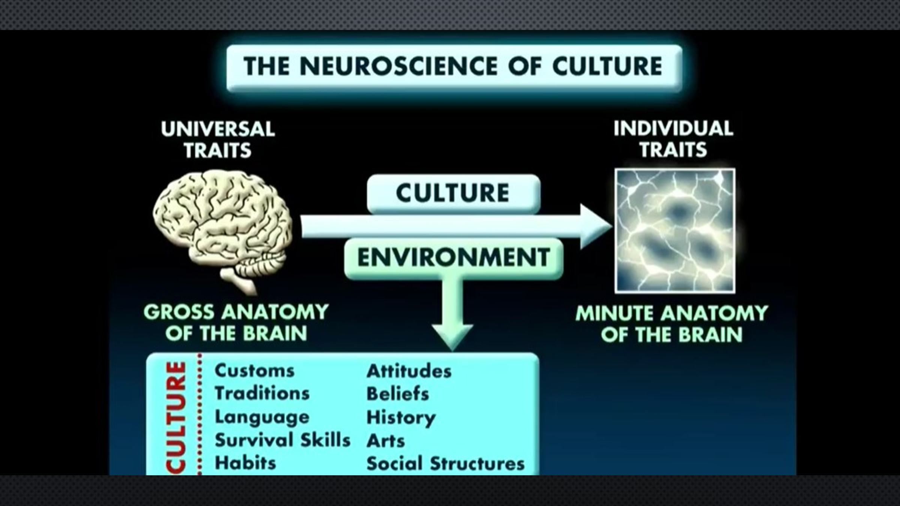 | This is a significant time of anxiety and stress for everyone. For educators, we want to share a few simple exercises that manually stimulate the vagus nerve, which is our 10th cranial nerve and also connects the brain stem to the viscera which affects our calm, fight/flight or immobilized, dissociated nervous system pathways. These exercises help to release the anxiety and embodied stress!  “By developing an understanding of the workings of our vagus nerve, we may find it possible to work with our nervous system rather than feel trapped when it works against us.” “Stimulating my vagus nerve has played a key role in the management of my mental health over the years.” – Dr. Arielle Schwartz, Clinical Psychologist  1. Cold showers for 30 seconds, splashing your face with cold water or an ice pack for a few minutes on your face or neck as needed.  2. Meditation/ deep breathing for a few minutes each day  3. Taking slow long deep breaths  4. Omega Three Fatty Acid supplements  5. Exercise even if it is a brief five-minute walk.  6. Probiotic  7. Humming, gargling, chanting, and deep sighing for a few minutes... even gargling with water!  8. Foot massage- you can give yourself one for a few minutes each evening.  9. Massage the right side of your throat where your carotid sinus is located!  10. Laughing and socializing, if even from a distance!  Dr. Joe Dispenza- The Neuroscience of Culture  https://www.youtube.com/watch?v=xF6Nur2S5eY  Resmaa Menekam  Guide for self-Reflection, self-care and awareness  https://rides.gse.harvard.edu/files/gse-rides/files/systemic_injustice_self-care_and_self-indulgence_1.pdf  According to Learning in Action Technologies (2002), there are 8 key things you can do in terms of daily practices to help in self-reflection:  - Practice being present now.  - Notice your judgments about yourself and your judgments about others.  - Practice noticing and naming your experiences.  - Focus on what you want, not what you don’t want.  - Recognize that other people are simply mirrors of yourself.  - Practice awareness by noticing the stories you create and your interpretation of them.  - Practice unbundling your feelings.  - Notice the degree with which your emotions, thoughts, and wants are positive or negative.  Daily Practices to Increase Empathy  - Practice acknowledging yourself.  - Practice acknowledging others.  - Get to know your team members.  - Practice tuning in to others.  - Learn and practice the essential elements of dialogue.  - Practice initiating conversations at times of stress.  - Practice listening without interrupting.  3. Staff Counter Aggression  The Seven Reasons We Can Become Dysregulated and lash out at students.  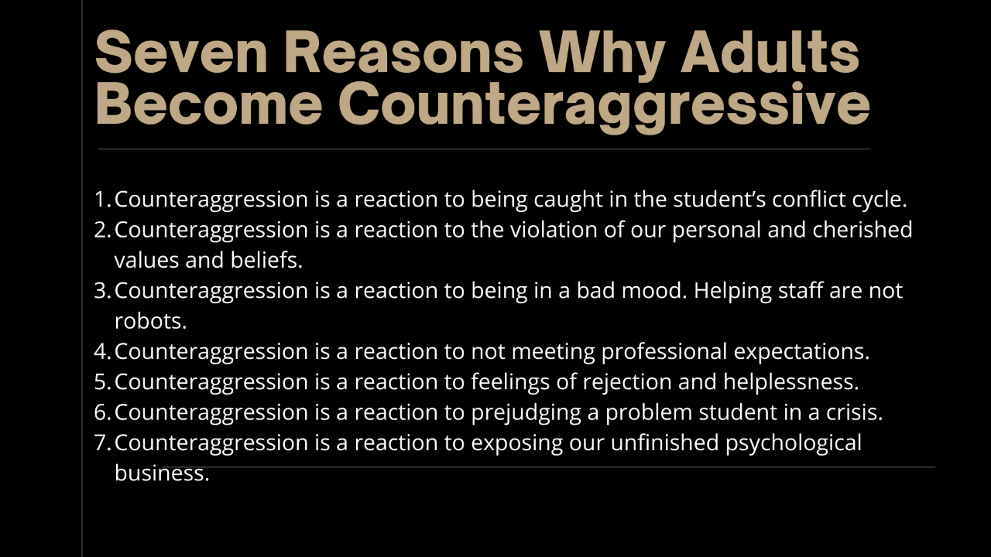  Below is Our Personal Button Pushing Chart

Personal Plan for Button Pushing
What am I sensitive about? | What do I think and feel when a student tries to push my buttons? | What do I do when one of my buttons is pushed? | How can I change my typical reaction?
Cleanliness/ When things feel, people or experiences feel unclean I become anxious or irritated
Neat and Organized/ I feel very dysregulated when there is disorganization and chaos
Prompt/ I am irritated when people show up late!
Hard-working/ Looking unmotivated or lazy triggers negative emotion in me!
Honesty/ I am angry when I am lied to!
Polite/ When people or students are rude or appear rude, I feel irritation, frustration and anger
Precise/ I like details and if plans, projects or anything feels vague, unclear, or even disorganized, I am bothered.
Sexually Reserved/ This can trigger me if there is too much skin, openness, or perceived provocative behavior
Emotionally Controlled / I am irritated when people are overly emotional!
Happy/ Too much happiness over things or experiences feels ridiculous or inappropriate to me

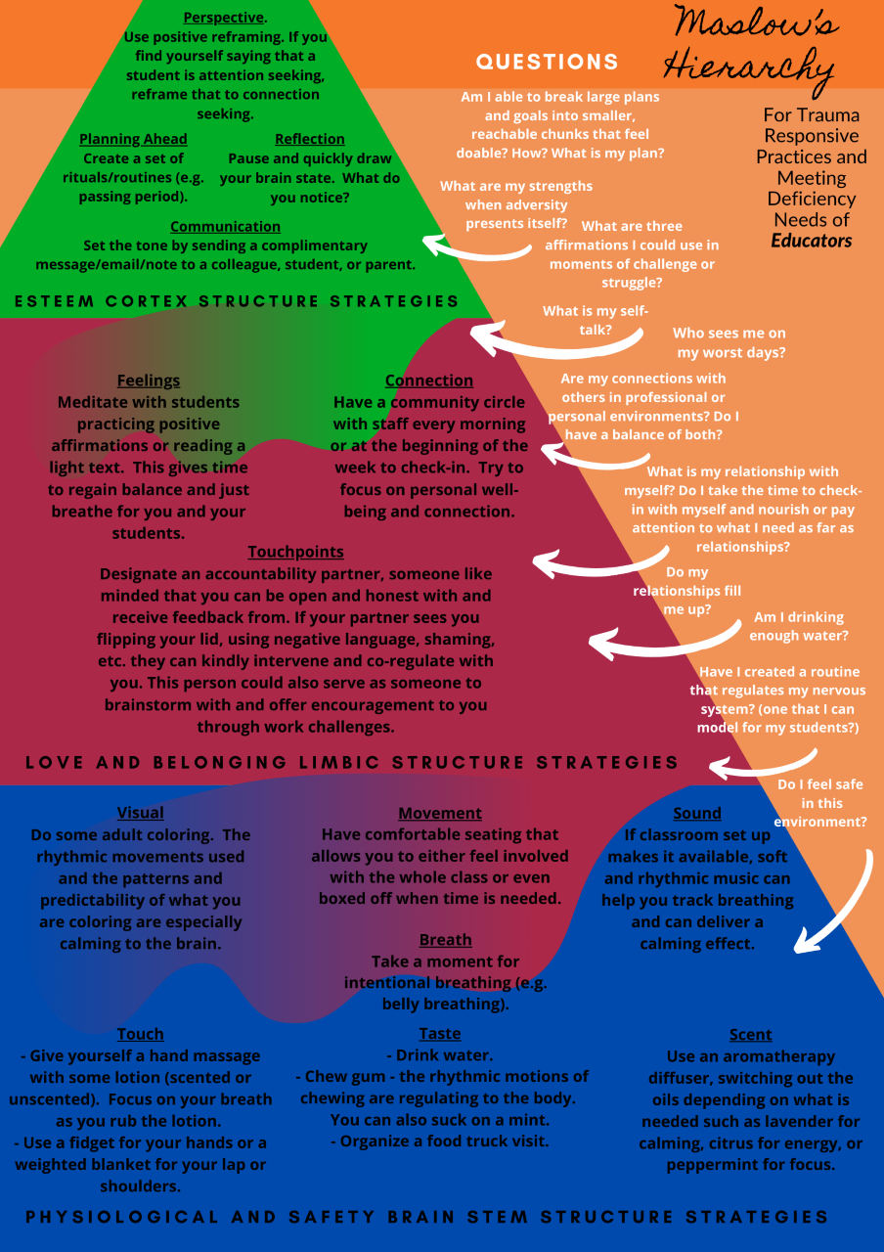

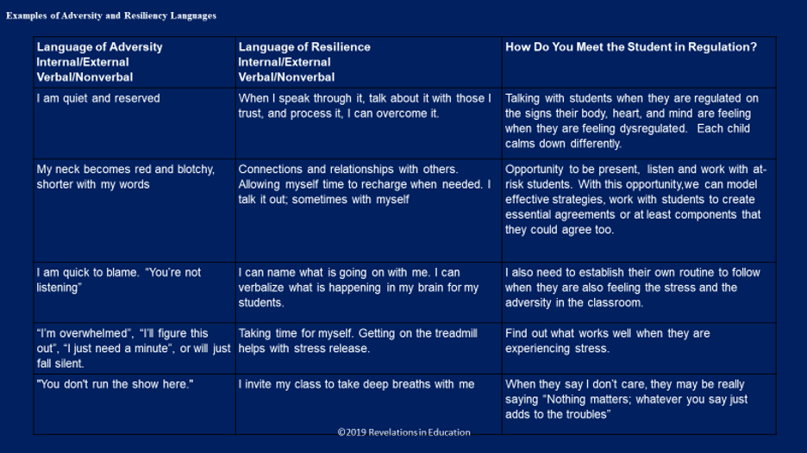
A New Lens for Discipline calls us to reflect upon on our own embodied experiences of how discipline was felt, sensed, and shared in our families and in our personal lives! Reflection separates good teaching and leadership from superior teaching and leadership!

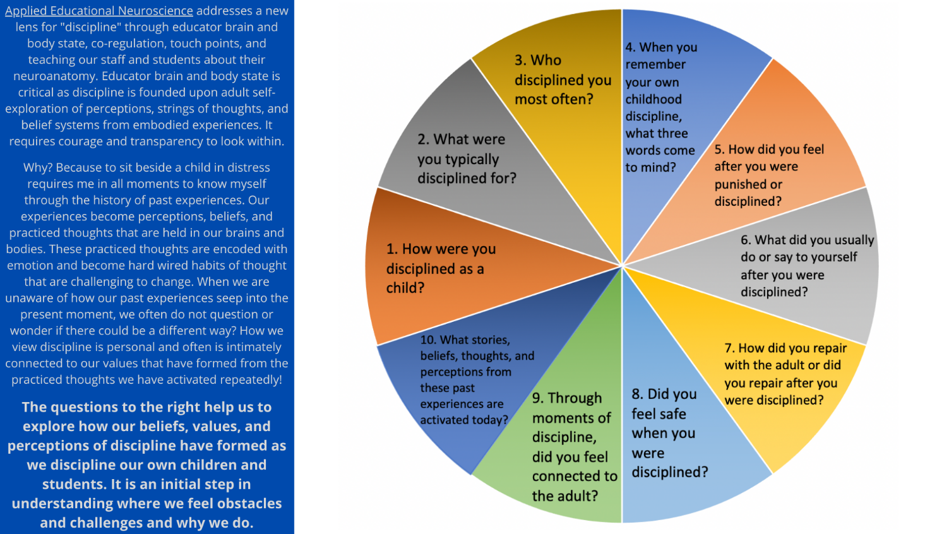

3. Regulation: the ability to recognize and work through one’s emotions and perceptions while exploring our belief systems, patterns of thoughts, and patterned emotional reactions. Regulation skills build healthy nervous systems that help us to feel grounded and empowered while generating feelings of self-efficacy. Regulation embraces the understanding that we recognize when we are stuck in the stress cycle and unable to move through negative emotions. The goal of regulation is to have awareness and recognize compromised brain and body states. When we are able to experience a regulated nervous system, we are also able to pause, reflect, and be curious before we react positively impacting our overall well-being.
Educator Learning Outcome: Educators will recognize and identify grounding practices that build emotional fluidity throughout daily decisions, interactions, body regulatory practices, and increased self-awareness.
Emotional regulation for adults is sometimes a more arduous endeavor and path because our habits, perceptions and behaviors have become hardwired circuits in our brains and bodies that often unintentionally leave out the cortex (the thinking and reflecting part of the brain) where we have accessibility for reasoning, reflecting, changing our minds, discerning, and filtering our emotional reactivity that rests in our words, thoughts, behaviors, and reactions. The brain and body learn from patterned repetitive experiences and the more we do, think, feel, or respond to certain events, people, situations, and perceptions, the more difficult these habits (hard-wired circuits) are to shift. Neuroplasticity is the good news! We can change how our brains and bodies react with each new experience and encounter. This too is a process and takes patterned repetitive experiences. Before we delve into practices and strategies, we need to ask ourselves a few questions strengthening self-awareness as we begin to address our own brain and body states for sustainable well-being. We must be aware of the Adverse Childhood Experiences Study and its significant correlation to emotional, mental, cognitive, and physiological health outcomes. https://www.cdc.gov/violenceprevention/acestudy/index.html

Grade Level | Indicator | Strategies & Practices
Educator | - Educators recognize life stressors and begin to develop practices and strategies to address mitigating these stressors before they arise.  - Educators initiate regulatory practices that allow a reframing and a shift of perspectives while holding a safe space for exploring feelings, thoughts, beliefs, and perceptions.  3. Using the polyvagal chart, educators are able to chart and track their brain and body states throughout the day at home or during the working hours. Understanding brain and body states yield patterns and insight leading to regulation as we recognize these trends during certain days, times of the day, or occurring during specific experiences.  - Educators identify anti-racism and social equity resources that align with their sensory, emotional, and cognitive well-being. These resources will assist in our personal and professional development of how biases and inequities are a significant facet of our everyday lives.  Questions to Ponder When Addressing Student Behavior  - Do certain students trigger me more than others?  - Are my responses to each student’s behavior the same?  - Which students do I redirect most often?  - What behaviors do they show?  - What behaviors do I expect to see?  - What emotion do I feel when certain students do not follow my directions?  - Which behaviors push my buttons most?  - What time in the day do I feel the most calm and happy with my students? (silence, chatter, students listening to me speak, students speaking to each other)  Addressing Regulation and Touch Points  - Which students do I feel the closest to in my class?  - Why do I feel connected to them?  - Which students are my “favorites?” Why?  - Do I understand the cultural identity of my students? If not, what can I do to learn more?  - Do I attempt to make connections to my students’ culture and backgrounds in an authentic way?  - Do my students feel safe to be their authentic selves?  - Am I creating a community of inclusion and equitable access? (everyone gets what they need, not the same thing for everyone) | 1. Journaling words, images, reactions, fears, insights, or any thoughts is a powerful activity for a few minutes each day. Below are a few topics to consider as we begin to create that emotional pause in our lives reflecting upon the outcomes, perspectives and feelings/sensations originating from ourselves and other individuals.  A. What do I say to myself when things do not go well? In other words, what is my self-talk? What could I begin to say replacing the negative words that have become my reactionary responses?  B. In difficult situations today, what are two positive outcomes I did not recognize in the moment?  C. Am I releasing control of what cannot be controlled, or am I holding on to the words and emotions of others that I have little to no control over?  D. Could I journal the perspective of another deeply resonating from their mind, heart, eyes, and words? What do I sense, experience, and feel from the child or adolescent’s perspective that I did not recognize in the moment of conflict?  2. Focused Attention Practices- Focused attention practices teach students how to breathe deeply while focusing on a particular stimulus. When we take two or three minutes a few times each day or class period breathing deeply, we are priming the brain for increased attention and focus. These practices might also include a stimulus such as sound, visualization, or the taste of a food. The focused attention increases oxygenated blood and glucose flow to the frontal lobes of the brain where emotional regulation, attention, and problem solving occur. These practices activate our parasympathetic pathway in the autonomic nervous system lowering our blood pressure, heart rates, and respiration. There are many “apps” that can create a schedule, rhythm, and a plan to help us implement these practices a few minutes each day with consistency. Below is an example of a simple Focused Attention Practice that we can begin to employ.  1. Sit with a relaxed, uplifted posture (you can sit in a chair); bring your full attention to your breath; when your attention strays, as it surely will, come back to the breath.  2. The hardest part is being distracted and that is part of the process. Trying to focus on your breath without getting caught up with what went wrong at work yesterday, or what you are having for dinner later tonight, or why that student was so disrespectful is a part of the learning process.  3. As you slowly, deeply inhale, try to hold your breath for a few seconds before the exhale, extending your exhale by a few seconds. We want to pull the oxygenated flow all the way down to our bellies, blowing up our bellies like a balloon. We begin slowly and for a short period of time. So on Monday, take five deep breaths a few times, Tuesday, 10 deep breaths, and gradually add a minute or two as you focus on the sensation of the air coming in and out of your nose each time.  If you think you are too inattentive, antsy, or fidgety for a Focused Attention Practice---think again. “Asking the mind to turn off is like asking the heart to stop beating.” It is impossible and it is not going to happen! Returning to the breath, again and again, trains the mind to be rooted in the present, not the past (work), the future (dinner), or a grievance. Our brains are organs that act like muscles and the more we strengthen areas and circuits in the prefrontal cortex, the stronger they become. Every time we take a few minutes to quiet our thoughts, it is likened to a set of bicep curls for the brain. In this way, a Focused Attention Practice is a little like being more awake: there is less anxiety and more action.  Below are body/ brain regulated practices and resources that create integration of blood flow from the body to the brain and from the brain back to the body. These are only a few minutes long and are beneficial for the whole family.  Healing Racialized Trauma with Resmaa Menekam and Tara Branch- https://www.youtube.com/watch?v=UQRkJecRBmw  Healing Our Thousand Year Trauma-https://medium.com/@rmenakem/healing-our-thousand-year-old-trauma-d815009ae93  Meditation with Breath- https://www.youtube.com/watch?v=WHCl6b9K25Y  Black Men Meditate-https://www.youtube.com/watch?v=qg2_ySHxSZY&list=UUf2r-iwoXLDmXR-9dLy1uUQ  Black Yoga and Meditations- https://www.youtube.com/watch?v=Myd8Oj2rP60&list=PLuAmo91fiNwzJyB-pqY3Gufb2Y9W-LrAJ  3. Harvard University Anti-racism Resources  https://projects.iq.harvard.edu/antiracismresources/bipoc/selfcare  4. Many of the practices below are for adults and students and can be modified, but all address the movement, rhythmic, and breathing practices that our bodies require to release tension, stress, and adversity.
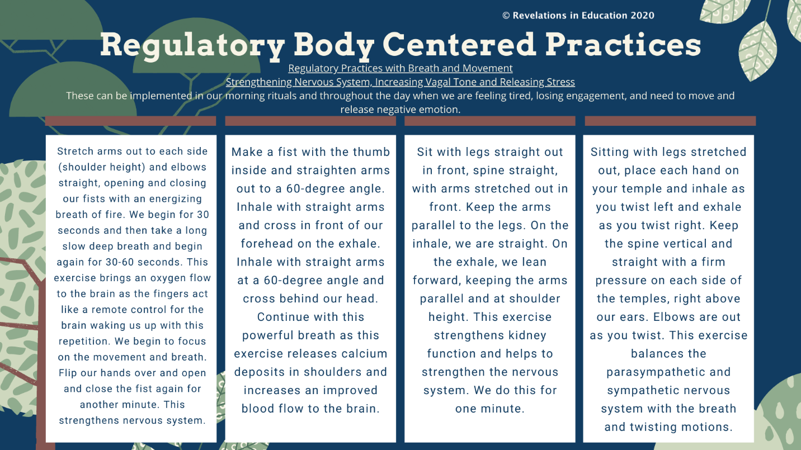
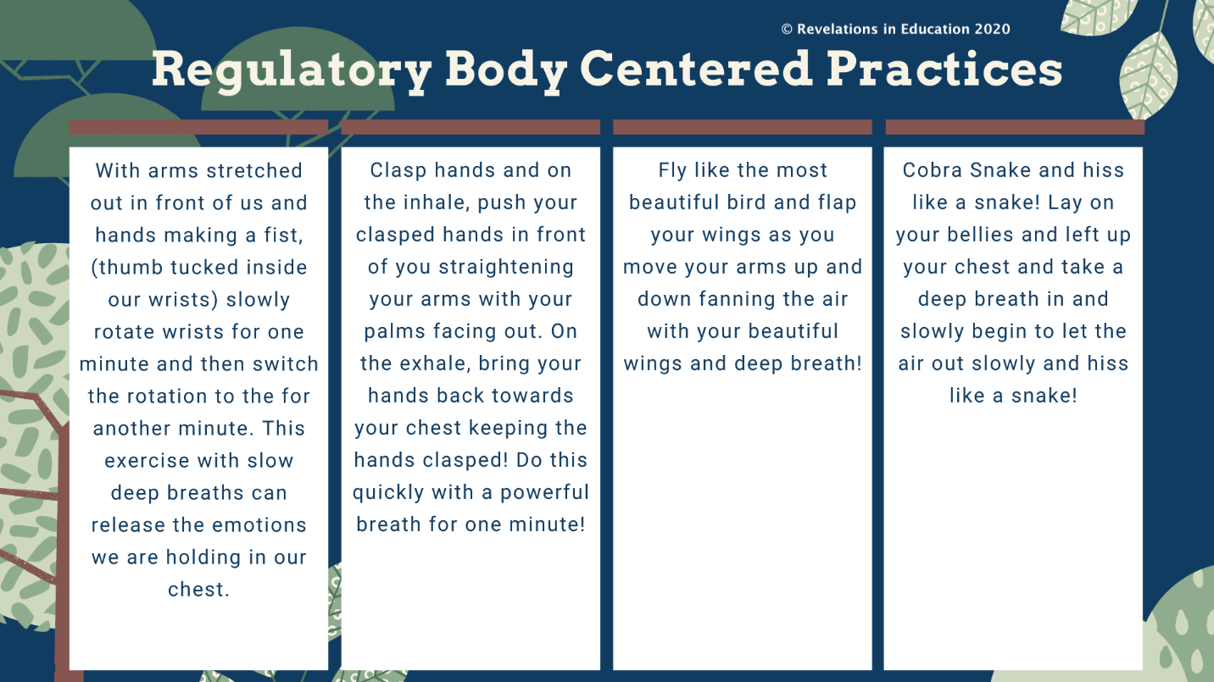
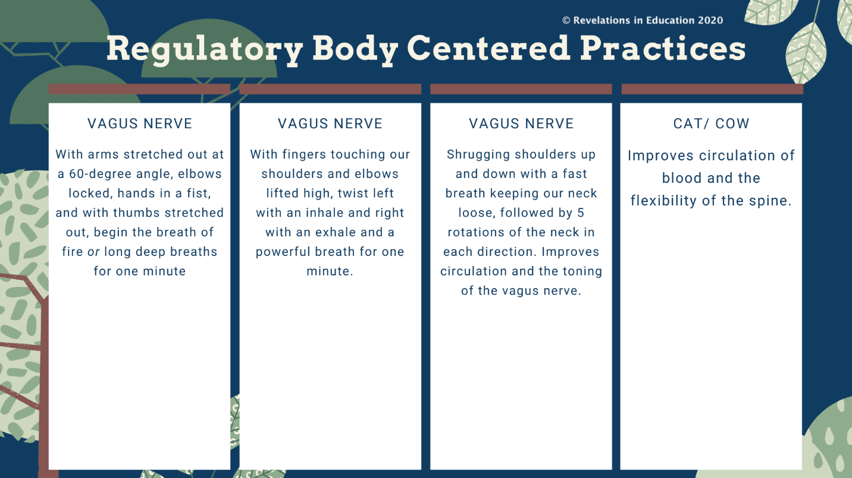
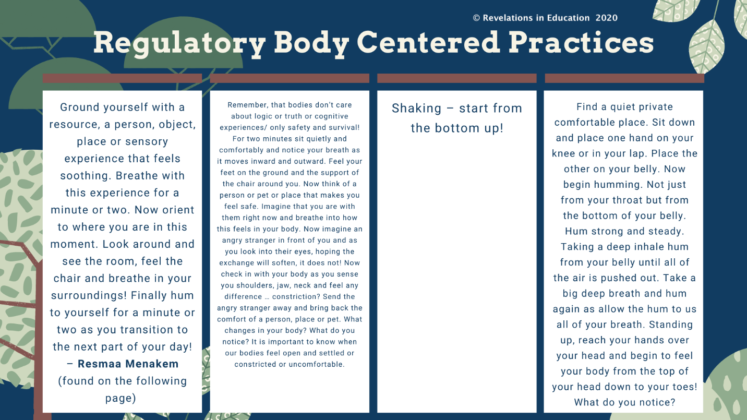
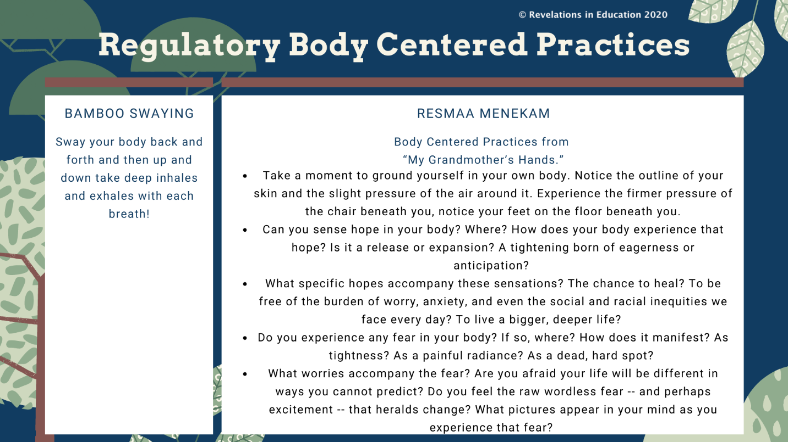

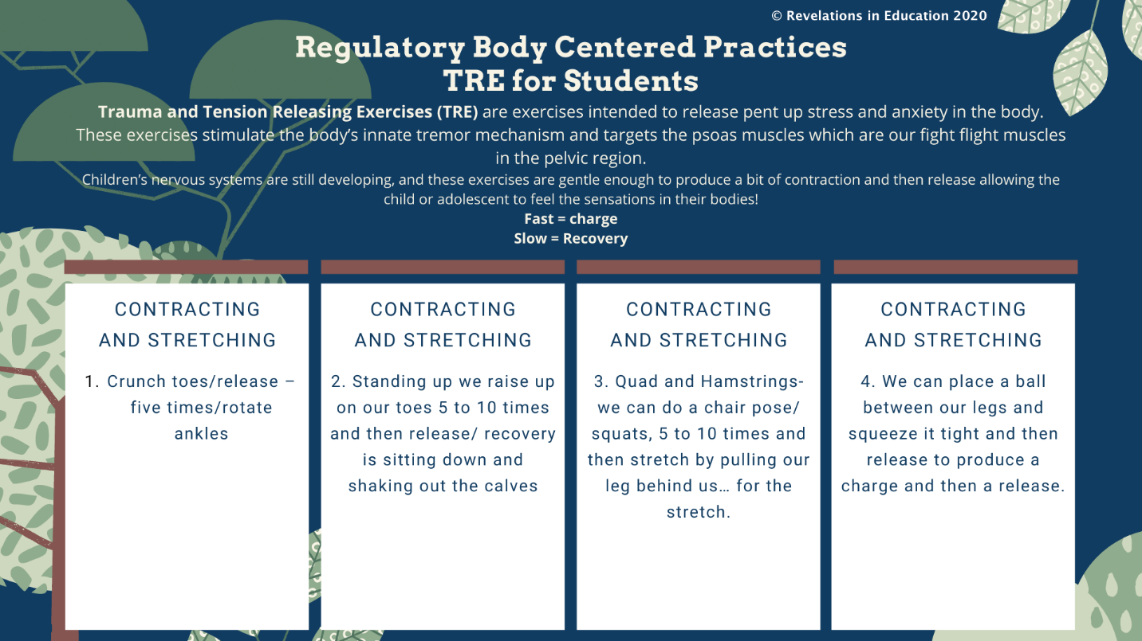
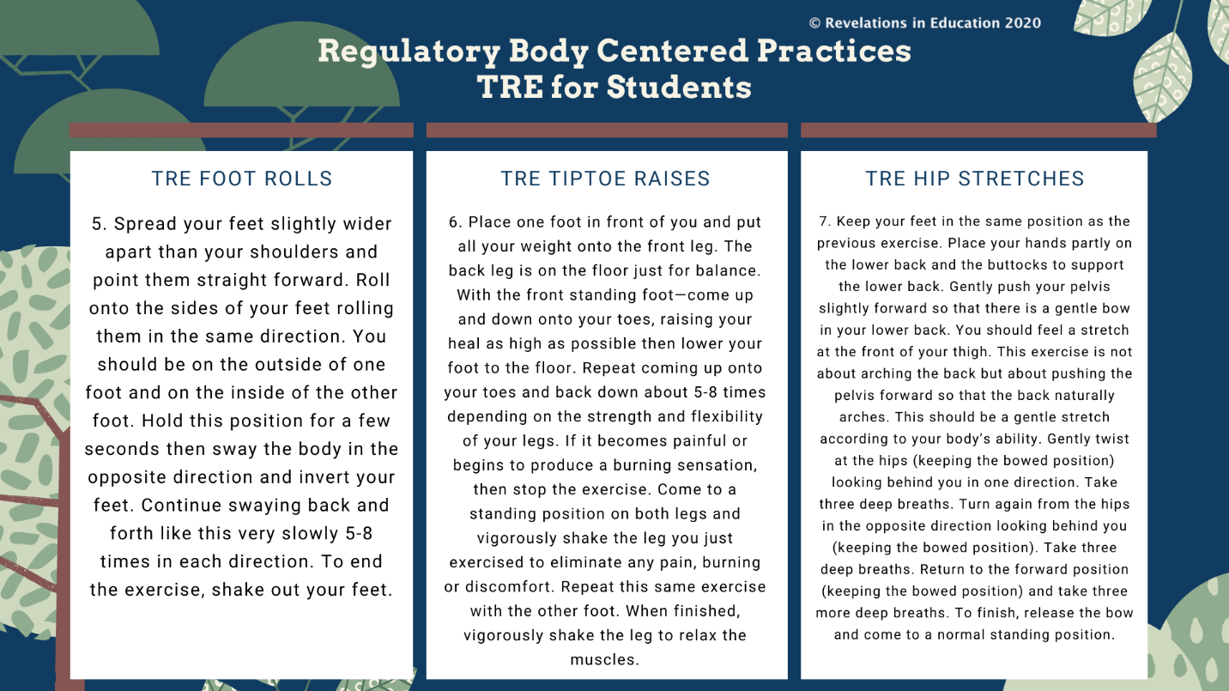
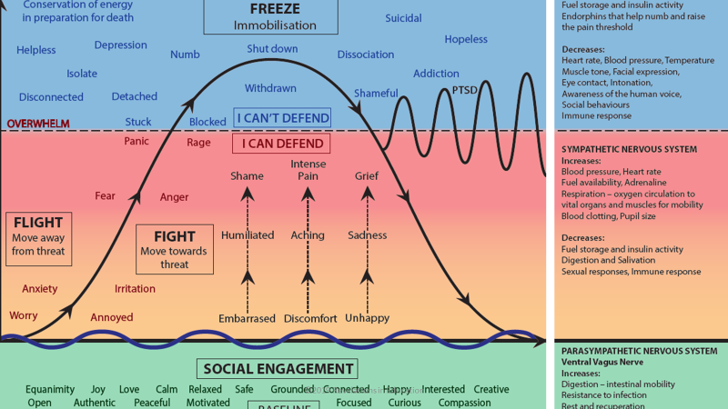

4. Connection & Collaboration: the ability to navigate and work within diverse social settings, understanding power dynamics, perspective of others, with deepened listening. Connection and collaboration work to build and strengthen touch points while cultivating positive communities that value multiple perspectives, identities, and experiences. Connection and collaboration call us to recognize how we begin to create a compassionate presence within conflicts and challenging interactions with others. The following chart will drive the practices in this competency and development.
Educator Learning Outcome- Educators will become aware and address their brain and body state before sharing their “calm” with a colleague or student. Connection and collaboration are a critical part of brain architecture as our bodies and brains are social organs. This competency is a process and requires self-reflection and insight into the diverse and multiple perspectives before we begin to connect and collaborate with colleagues and students who carry in a variety of cultures, diversity, histories, values, perceptions, belief systems, and feelings.
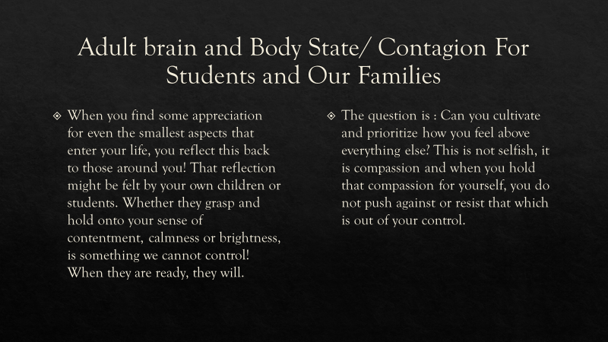
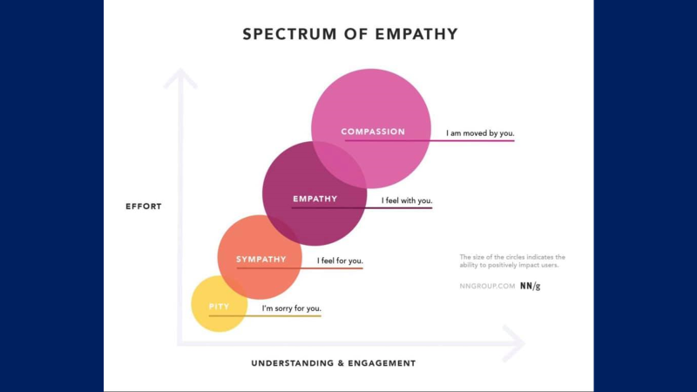

Grade Level | Indicator | Strategies & Practices
Educator | 1. Educators will recognize the power of relational contagion and how our nonverbal communication affects the majority of our communication.  2. Educators will be able to identify how white body advantage consciously or subconsciously plays into the interactions with persons and students of a variety of cultures.  3. Educators will design collaborative brain aligned restorative circles to discuss the challenges we face with one another as we address the challenges in our schools, with students, and social and racial inequities in our schools and how these outward inequities can traumatize students.  4. Educators will begin to implement touch points which are moments of connection that can regulate and calm another adult or student when we validate, notice, and implement the power of questions.  Examples of Questions  1. Once we feel a shift in our nervous systems, we can access our cortex and the parasympathetic pathway that produces a lower heart rate, respiration, and lowered blood pressure and clarity of thought and memory. The following are questions that are critical to reflect upon when we encounter challenging behaviors with our students.  A. What do I say to myself when things do not go well? In other words, what is my self-talk? What could I begin to say replacing the negative words that have become my reactionary responses?  B. In difficult situations today, what are two positive outcomes I did not recognize in the moment?  C. Am I releasing control of what cannot be controlled, or am I holding on to the words and emotions of others that I have little to no control over?  D. Could I journal the perspective of another, deeply resonating from their mind, heart, eyes, and words? What do I sense, experience, and feel from the child or adolescent’s perspective that I did not recognize in the moment of conflict?  Questions to ask ourselves with our most troubling students:  What else is going on here?  What does this child need?  What keeps me only looking at the behavior?  What is this behavior communicating about the student’s nervous system right now?  What in the environment could be triggering this behavior?  Questions That Address Collaboration and Neuroplasticity  Consider:  •Are my responses to everyone the same/consistent?  •Which students make me feel the most frustrated?  •Do any of my students remind me of (or do I associate them with) something positive? Negative?  •Do certain students trigger my survival brain? Am I willing to examine this without judgement and with honesty?  •Do I truly believe that each students’ brain is capable of the same outcomes, regardless of race, ethnicity, gender? | 1. Educators will address their tones of voice, postures, gestures, and facial expressions through learning the supportive research. https://www.youtube.com/watch?v=cef35Fk7YD8&t=555s  - Hand Signals Show Trust  - Numbers  - Increase or Decrease (Big challenges or small challenges) through gesturing for understanding.  - Hands Behind Back- signals distrust and anxiety because we are missing a significant part of the communication.  - Emotional- gesture by your heart  - No Pointing- aggressive  - Bring things together with welcoming clasped hands.  2. Reading and sharing the work of Resmaa Menakem through “My Grandmother’s Hands” with accompanying podcasts will assist us in addressing white body trauma, black and brown body trauma, and how racial and social inequities are held and measured by the standard of white bodies.  https://onbeing.org/programs/robin-diangelo-and-resmaa-menakem-in-conversation/ Robin Diangelo and Resmaa Menakem  https://ed.stanford.edu/news/racial-disparities-school-discipline-are-linked-achievement-gap-between-black-and-white?fbclid=IwAR20QjBPZknaBW8UxL1PYG4N1ZRAv8J1umU20xF3F--7bFvYpdSAVhey7E0  http://revelationsineducation.com/resources/racial-and-social-equality-resources/  Sharing a space to discuss these practices and the text of the book and podcast as grade levels, staff, and departments discuss racial and social inequities as these conditions relate to discipline and the overall well-being in our lives.  3. Brain Aligned Restorative Gatherings bring us together focusing on solution-oriented decisions and responses. See Below: https://endseclusion.org/2020/11/14/brain-aligned-restorative-circles-addressing-the-core-of-discipline-challenges/  4. Touch Points- Moments of connection where we are intentional about sharing our calm through the practices of noticing, validation, active constructive responding, and questions.  https://www.gse.harvard.edu/community-learning/diversity-equity-inclusion-belonging/resources  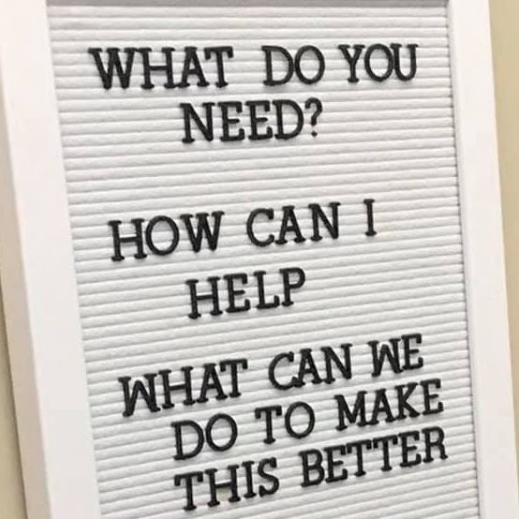

Brain Aligned Restorative Circles
Addressing Connection and Collaboration with Challenging Topis in Our Schools
Restorative Circles and Practices have been implemented for a significant amount of time inside schools. There are hundreds of articles and resources sharing this framework and its purposes for building community and for responding to challenging behavior through authentic dialogue. As we enter new school years and semesters, we are already seeing many students struggling with anxiety, depression, and unrest seen through their behaviors. We are in chronic unpredictable times with different schedules, changing routines that are taxing, and the wearing of masks. Traditionally, Restorative Circles and Practices attempt to shift the conversation between teachers and students to be less punitive, offering an opportunity for all persons affected by an altercation to have meaningful dialogue about how to make things right and restore the classroom community. They are also powerful for building community in neutral times.
In this time of unprecedented trauma, adversity, racial and social inequities, staff and students are carrying in an exorbitant amount of fragmented and unprocessed sensations and emotions that are highly contagious and these emotions can be activated below the water line of consciousness. These sensory and fragmented body and brain sensations are held as implicit memories and can fire off in emotional outbursts, impulsive actions, shutting down, and possibly look aggressive. We are not excusing behaviors, but we need to understand that all implicit body memories when they are active have the quality of happening right now- likened to visitors from our eternally present past.
One of the challenges with traditional restorative practice and circles is that these are “talking” circles and are attending to the cognitive parts of the brain (the prefrontal cortex) that are often turned off when we are experiencing growing frustration, irritation, anger, anxiety, and worry. When we are feeling and sensing unsafe environments and feeling isolated, we are unable to problem solve, emotionally regulate, listen deeply, and attune to others. There are neurobiological reasons why traditional restorative practices may work in the moment or for brief amounts of time, but they are not producing sustainable changes in behaviors and collaboration within school cultures!
Our brains and bodies change dramatically when we are chronically stressed. For example, we have an inner ear muscle (stapedius muscle) that expands when we are experiencing negative emotion and pays attention to all sounds in our environments, prohibiting us to attend to a direct conversation or directive. This inner ear activation is for our survival and is the body’s protective mechanism. It will constrict when we feel safe. This is true for adults as well. Many students and adults are walking into these restorative circles with activated emotions in the form of deep grievances that call for control, respect, and are seen as defensive through our postures, gestures, tones of voice, and facial expressions.
When we review our district’s or school’s discipline data, we will generally see the same groups of students being secluded, suspended, or punished in ways that can unintentionally reactivate their developing stress response systems and can retraumatize children and youth who carry in significant pain, adversity and trauma.
In a Brain Aligned Restorative Circle, we prepare our brains and bodies for regulation by providing a bottle of water, a pen, blank canvas or board, or small notebook. We explain that when you draw or journal to name or reappraise your emotions and sensations, they lessen. https://starr.org/bust-worry-anxiety-with-expressive-arts-activities/ Our goal is to create a sensory repairing environment before words are spoken. As we prime our brains for learning, we might listen to music for the first two minutes, take a focused attention practice with our breath while drawing our sensations on a graffiti board as we prepare for our reparative and restorative circle. Below is a sensory word wall where staff and students can choose a sensation giving it a shape, lines, color, or an image. This is always a choice. The facilitator explains and reminds everyone that for our brains to solve problems, listen deeply, and attend to one another, we must activate the cortex of our brains where our most creative and innovative thoughts arise. When we are functioning from our cortex, we feel calm and clear. The facilitator shares that our brains process survival and safety and that our feelings are as contagious as a virus. When we are in a survival state, our hearts speed up and our blood pressure increases prohibiting us from thinking clearly, reasoning, pausing, and paying attention in the moment so we are able to reflect our thoughts and feelings back into the circle. https://www.edutopia.org/blog/the-science-of-fear-ainissa-ramirez
1. Educators Only-- What if schools begin creating Brain Aligned Restorative Practices and Circles with staff modeling these discussions and resolutions within an inner circle, while students in the outer circle listen, critique, give feedback, and reflect on the staff dialogue. This fish tank circle could be recorded and shared at various times with a variety of grade levels, so all students are exposed to these conversations. When we model our conflicts, sensations, feelings, with a variety of possible resolutions, we are empowering our students with the ability to share freely, without judgment, and to experience how a crisis can lead to connection. Below are possible suggestions for questions.
Questions for Adult Circles
1. When we speak about how trauma and adversity affect us each uniquely, what sensations do you experience in your body or brain? (tight jaw, pressure, shaking, shortness of breath, tiredness, rapid heart, etc.) How has the wearing of a face mask affected your teaching or leading?
2. When you have difficult conversations met with resistance, how do you typically handle your sensations and emotions and what would you like to improve? How do you get to the cortex so you can find calm?
3. What does racism look like in this school? How is racism connected to our discipline practices? Where so we begin when addressing systemic racism in education?
3. When you think of an experience where you felt fear, felt threatened, or anger, was it difficult to think clearly and remember? How did you respond? What was the outcome?
4. What are your greatest challenges at school in this time? How are you handling these? Do you have a plan? How are you caring for your brain and body?
5. What are your greatest strengths? Do your strengths show up when you begin to feel regulated? If not, what can you do?

2. Talking Piece and Circle Agreements – Talking pieces and agreements need to be created by the students and adults. These agreements are created ahead of time and are subject to change based on the needs of the circles. Talking pieces can be created and chosen by everyone alternating a variety of these pieces for the specific conflict or challenge and grade levels and classes can begin constructing talking pieces at the beginning of the academic year with ongoing creations. Do these pieces reflect student and educator interests, passions, and purposes?
2. Embodied Lived Experiences- We might ask educators and students to bring and share a childhood photo to the circle. As we pass the photos around, we are reminded by our facilitator that we all share infancy, childhood, and a beginning of life where we each have experienced environments, relationships, along with some pain and hurt that is often misunderstood and not known to others. This is an important time to remind our circle that brains and bodies develop from experiences and those experiences become our values, beliefs, histories, perceptions based on patterned repetitive experiences. Connections with people can help us integrate, make sense, and reframe our developing perceptions from those experiences. We remind one another that our brains are historical, social, and experience dependent organs that act like muscles, always predicting experiences based on past experiences.
3. How Are We Similar? How Are We Different? We begin our restorative gathering by sharing our baby or childhood photos as we notice similarities and not differences from our shared images. As we move through the circle, we share other similarities that we notice in the present moment circle.
What are three ways we are alike one another in this circle?
What are three ways we are different from one another in this circle? Do these differences cause challenges for us? How?
How can differences bring us together?
Am I important to someone here in this class or school?
Can I share my strengths and gifts in this school or class?

- What was our challenge?
- During this challenge, what were you feeling in your body? ( hot, sweaty, headache, seeing red, hearing black-out, tight chest or muscle tension, rapid heart rate)
- Do you recall any thoughts you were thinking?
- What do we think or feel led up to our challenge?
- How did we handle it? Can we think of one strength we implemented or wish we would have implemented?
- If we both get a do-over, how could we handle this more peacefully ?
- What are two adjustments in our nervous systems, thoughts, and actions we will try the next time?
- How? Let's create brain map of our plan!

4. Brain Aligned Questions for Resolving Conflict in a Brain Aligned Restorative Circles
To understand the suffering of others, we must first touch our own suffering and listen to it.
Thich Nhat Hanh
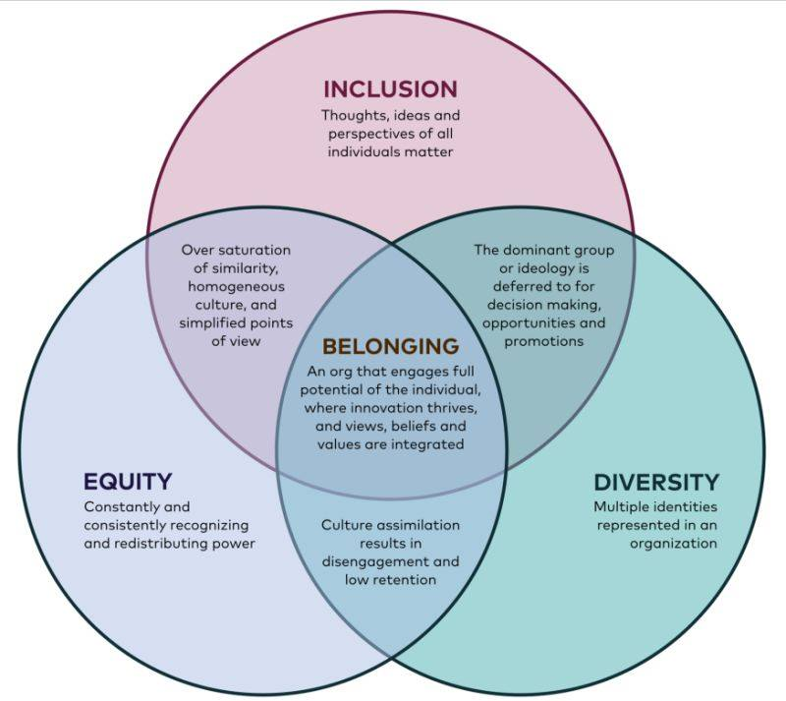

5. Mindset- the ability to demonstrate cognitive flexibility and a willingness to learn. Developing mindset is a critical learning skill for building perseverance, adaptability, self-discovery, resilience, and the capacity to receive and give constructive feedback. Our adult mindsets are often unconsciously activated when we feel unsafe, disconnected, or threatened. Our ego can get in the way of much needed shifts in our perspectives. A mindset that is open and receptive is one that acknowledges racial and social inequities and how we each can learn about our implicit biases, cognitive biases, ability to change our thoughts, perceptions, and feelings. Growth Mindset is neuroplasticity. Neuroplasticity is our brain’s ability to change structurally and functionally based upon our moment-to-moment experiences. This is the brain’s ability to adapt and rewire itself so we can not only survive but thrive in throughout the challenges in life. Our thoughts, feelings, sensations, and behaviors are intimately connected to the functioning of brain and body architecture and the bi-lateral connections between them. The more patterned repetitive experiences we provide our brains and bodies the more neural agility they will develop.

Grade Level | Indicator | Strategies & Practices
Educator | 1. Educators will begin to understand how our brain and body systems change structurally and functionally in moment-to-moment experiences.  2. Educators begin to identify the “gift” of a mistake, perceived failure, or negative bias that has lodged itself into thinking and feeling patterns in our bodies and brains.  3. Educators will identify thoughts and feelings we awaken to and initiate first thing in the mornings. How do these patterns and hard-wired routines play into past worn out beliefs and perceptions? “The Mind is the Brain in action.” -Dr. Joe Dispenza  Questions to Ponder.  1 Am I able to plan my behavior for the day?  2. What is the greatest expression of myself I can present to the world today?  3. Who do I want to be when I open my eyes?  95% of who we are by the age of 35 is a habit of mind and becomes our state of being. A habit of mind is practiced thoughts and emotions that have been memorized. “Evolve Your Brain.” -Dr. Joe Dispenza  Every time we have a thought, we create a neural chemical that aligns to our thoughts. “You think the way you feel and then you feel the way you think, and then you repeat this for days, weeks, months, and years.”  4. Educators will identify how they are caring for the minds.  What type of thoughts am I planting?  Did You Ever Grow Anything in the Garden of Your Mind?  1. How are our brains like gardens?  2. What do plants need to grow? What do brains need to grow?  3. What do you think thought seeds might mean? What are feeling seeds?  4. What would you need to think about and have as you plant your garden?  5. What would you need as you think about healthy brains and bodies?  - Let’s plant a garden in our classroom and in our brains and watch it grow!  - Our gardens need water, sunlight, and good soil. They may need shade and a protective fence?  - Keeping a journal, which is a touch point keep track and share some of the following provocations…  - Who watered you this week?  - Who is your sunlight? Who can see the best and brightest in you when you or others cannot?  - What places help you to feel safe? What people?  - What sounds? What types of rooms or outdoor areas?  - Who protects you? What do you do to self-protect?  5. The Hero’s Journey:  Educators will identify the stages of the Hero’s Journey in their own lives as they continue to move through the challenges, obstacles, and opportunities that unfold with the teaching and learning processes.  Joseph Campbell's The Hero's Journey is relevant in all moments! Each one of us have entered this journey several times in our lives. I have added a very schematic description of how our brains and bodies respond to each stage and hour!  Questions to Ponder for Educator Brain and Body State A New Lens For Discipline!  How can we share our journeys with each other to create and strengthen relationships in our buildings and districts?  How can we integrate the Hero’s Journey into our discipline practices?  How would restorative circles change if they were story focused? (Our brains respond to patterns, analogies, and predictable experiences. We make sense of our experiences, perceptions, and worlds through stories.)  How can we share the section and hour of “assistance” in the interpersonal in-between space?  Are we able to tap into the love languages of our students and one another in this interpersonal in-between space?  How can we model the Hero’s Journey for our students through adult restorative circles sharing our hours of adventure, crisis, and resolution?  Can we begin to share the science beneath our behaviors, so we are intentionally discussing our neuroanatomy and not pathologizing anxiety, depression, emotional disturbances, or behavior disorders? | 1. For one to two weeks, choose a habit of thought and journal the reoccurring thoughts that tend to follow this experience. During this time, question those repetitive thoughts as science shares that we tend to think that every thought is true.  Through this week of journaling and becoming aware of our thoughts, notice the feelings and sensations that accompany those thoughts. Write those feelings and sensations down or draw images of those body languages that accompany those thoughts. This exercise begins to grow our mindset.  There is no formula for journaling, and it is difficult to write gratitudes on hard challenging days, feeling as if this is one more thing we need to do! As we begin to explore and become aware of our sensations, feelings, and thoughts, we can begin to think and journal about these questions.  1. How did you awaken this morning?  2. What did you notice about your body and your surroundings immediately?  3. What are you feeling in your body today?  4. What are you sensing?  5. What has triggered you the last few days or past week and how do you know?  6. How did you cope?  7. Can you think of one gift or positive aspect from these negative conditions or experiences?  8. How could you move into appreciation for this condition, experience, or struggling relationship?  9. Can you draw these sensations, feelings, and thoughts?  10. Can you create a feeling or sensation map through imagery or words of this past month or the last few months?  11. How do you sense joy in your body?  12. How do you sense danger?  13. What feels unsafe to you in this time?  14. What places, things, or environments feel uplifting?  15. What people inspire you, bring you a sense of calm, and feel peaceful? What is it about them that can create these states of well-being?  Neuroplasticity Documentaries - Neuroplasticity  https://www.youtube.com/watch?v=bbLP-as1ABk  Neuronal Agility- https://www.youtube.com/watch?v=Jq0n8vgggU0  Dr. Richie Davidson  https://www.youtube.com/watch?v=7CBfCW67xT8  The Neuroscience of Culture -Dr. Joe Dispenza https://www.youtube.com/watch?v=xF6Nur2S5eY  2. The Gift- this group exercise is a co-regulatory practice where we share in a discussion, how our mistakes, failures, or negative biases could be gifts in our lives. We begin to shift with curiosity, questions, and wonder through the perceptual lens of another. We begin to understand how our thoughts, feelings, and sensations following an experience begin to lean into the negative! With a partner, share a practiced pattern of thought that feels challenging in your life. As you share this experience and the accompanying thoughts and feelings, your partner will begin to generate a variety of angles and perceptions for you to explore.  3. Questions for Reflection and Discussion  A. What is the greatest expression of myself that I can present to the world today?  B. Who do I want to be when I open my eyes?  C. Plan Your Behavior for the Day  D. Can you focus on one aspect of your routine that you could change each morning and evening for 30 days?  Dr. Joe Dispenza- https://www.youtube.com/watch?v=6lbnrRqBjgE&t=5s  Text- Dispenza, Joe, Evolve Your Brain, Health Communication, Inc. Deerfield Beach, Florida, 2007.  MEDITATIONS  Guided Meditation for Black Women  https://www.youtube.com/watch?v=5rNh_MwulX0  https://www.youtube.com/watch?v=WHCl6b9K25Y&t=189s  https://www.youtube.com/watch?v=5rNh_MwulX0  https://www.youtube.com/watch?v=S5LgKlQ4hMU  Most Powerful Short Guided Meditation On The Planet | Dr Joe Dispenza  Most Powerful Short Guided Meditation On The Planet | Dr Joe Dispenza JUST FOUND THIS CHANNEL? WATCH THIS! When You Feel Like Giving Up | Dr Joe Dispenza link: https://youtu.be/eAxu_4WfQTE How Meditation Can Transform Your | Dr Joe Dispenza link: https://youtu.be/xFbmN5JCOCY This Really Works!. "A 4 Day Process" - Dr Joe Dispenza [2020] link ...  www.youtube.com  https://www.youtube.com/watch?v=srBoq3wzZ84  BEFORE SLEEP SPOKEN GUIDED MEDITATION (Dr. Joe Dispenza) - WATCH THIS | By Wolf&Angel  Before going to bed is always important to have a clear mind from stress and negative thoughts. Keep in our mind only the things they bring us love, joy and fulfillment. The things we have or even things we want to achieve in our life. Our subconscious mind never stops working and especially during the night, whatever we focus on works on our ...  www.youtube.com  https://www.youtube.com/watch?v=riStMnJ3v9Y  Dr Joe Dispenza (2020) Guided Morning Meditation  Dr Joe Dispenza (2020) Guided Morning Meditation Here In This Video Dr Joe Dispenza Guides You In His Guided Meditation To Reprogram Your Mind #JoeDispenza #DrJoeDispenza #JoeDispenzaMeditation 👉Fan of Dr. Joe Dispenza? Check out also our playlist for more educated videos: https://bit.ly/2UcXGaW 🛎️ For more inspiring and motivation ...  www.youtube.com  Short Powerful Heart & Brain Coherence Guided Meditation FOR EVERYONE! | Dr. Joe Dispenza  Short Powerful Heart & Brain Coherence Guided Meditation FOR EVERYONE! | Dr. Joe Dispenza SUBSCRIBE TO THIS CHANNEL: https://www.youtube.com/channel/UC5kOnPbeGiFOByIO2Y9gSUw?sub_confirmation=1 DR. JOE DISPENZA | BEST VIDEOS [playlist]: https://www.youtube.com/playlist?list=PL8rP39o2WXw45Skw9XWZ-E0eYR4wSA_Fi DR. JOE DISPENZA'S WORK: Website ...  www.youtube.com  The Garden of Our Minds  https://www.youtube.com/watch?v=JnjiKFd4jZI  https://www.therealizedman.com/  Cognitive Group Bias  https://www.youtube.com/watch?v=N3vLG7MOuf4  5. The Hero’s Journey  https://www.linkedin.com/pulse/brain-aligned-heros-journey-lori-desautels/?fbclid=IwAR3tiVFRHtTMrwpTxDvk0LF00SPq41AaRuvd5l1MOBijmndadFJjD1N5roA  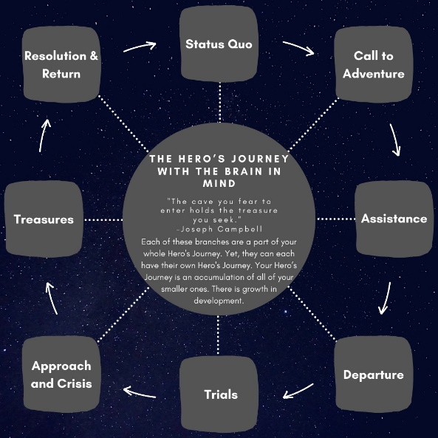  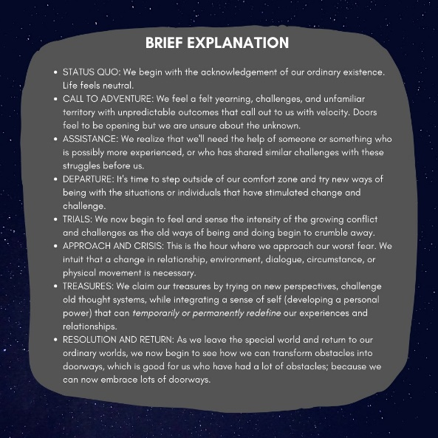

Dr. Lori Desautels ©
Assistant Professor
College of Education
Butler University

Revelations in Education ©
Butler University

