Practice and Strategy | Implementation and Application | Resources and Research
Neuroplasticity and Our Brains- SUPER POWERS!  Our brains act like a muscle, but they are organs! They need a good work out for us to feel peaceful and learn well. | What do you know about the brain and what are all the things it controls? Let us make a list!  We are visiting inside a real brain lab at the university. This is especially important as you begin to learn the different part of the brain and why your feelings, emotions, thoughts and behaviors originate or come from your brain and body states.  https://www.youtube.com/watch?v=_aCCsRCw78g  How connections are made in the brain! – Plasticity is our innate ability to create and strengthen between neurons!  New video - https://www.youtube.com/watch?v=_nWMP68DqHE | https://www.youtube.com/watch?v=ELpfYCZa87g  https://www.youtube.com/watch?v=9D--qD9rcuA&list=PLCnDPDwzKDvLrIgSiTeVVdmjhVICzCAs1&index=7  Neuroplasticity  https://www.youtube.com/watch?v=34lfJpvAGoU&list=PLCnDPDwzKDvLrIgSiTeVVdmjhVICzCAs1&index=14  Sentis videos- https://www.youtube.com/watch?v=ELpfYCZa87g  Neuroplasticity - Neuroplasticity- Another new video  https://www.youtube.com/watch?v=bbLP-as1ABk  100 days of Educational Neuroscience  https://www.doe.in.gov/sites/default/files/sebw/educational-neuroscience-toolkit-cover.pdf
How does the brain learn and work? Prefrontal Cortex and Amygdala | - What have you learned to do well?  - What is hard for you to do?  - How do you become better at doing something? What can you do? This is neuroplasticity! | https://www.youtube.com/watch?v=XSzsI5aGcK4&list=PL4BSHDH3YDXutTYQ4zNzcn_IqfhuStxPJ&index=1  How does the brain work?  https://www.youtube.com/watch?v=-nH4MRvO-10&t=11s
1. Hand Model of the Brain  2. Focused Attention Practices and Brain Intervals  Focused Attention practices calm our nervous system and help us to pay attention. Brain Intervals wake us up and engage us! These prime the brain for learning. | Hand Models showing how the brain builds networks and circuits-  1. Role of the prefrontal Cortex  2. Role of the amygdala  Think of times this week you were functioning from your prefrontal cortex?  Think of times you were functioning from your amygdala? | Videos (5 minutes ) https://www.youtube.com/watch?v=2xeDcPBD5Fk  . Brain Intervals and Focused Attention Practices- what are these? https://www.youtube.com/watch?v=fSLlrBxfHwI&list=PLCnDPDwzKDvLrIgSiTeVVdmjhVICzCAs1&index=17- Brain Intervals  https://www.youtube.com/watch?v=352hM1jUA8A&list=PLCnDPDwzKDvLrIgSiTeVVdmjhVICzCAs1&index=6- Focused Attention Practice  https://www.youtube.com/watch?v=352hM1jUA8A&list=PLCnDPDwzKDvLrIgSiTeVVdmjhVICzCAs1&index=6  Focused Attention Practice #1 - YouTube  Enjoy the videos and music you love, upload original content, and share it all with friends, family, and the world on YouTube.  www.youtube.com  Brain Intervals- What are these? https://www.youtube.com/watch?v=rekBxI8yqvc&list=PLCnDPDwzKDvLrIgSiTeVVdmjhVICzCAs1&index=10  Brain Intervals - week 10  and share it all with friends, family, and the world on YouTube.  www.youtube.com
Feelings and Sensations  What are feelings and how does our brain and body create feelings?  What are sensations?  Emotions are Contagious! | Feelings are felt in our brains and our bodies. They are created from the hormones and neurotransmitters in our brains and bodies. Feelings guide us through our days and when we are off track, our feelings let us know.  Sensations are physical feelings we feel in our bodies. They are the language of the body and when we recognize these as “normal” ways our bodies speak to us; this feels calming and relieving.  As we come into class, we can choose a sensation out of a jar or pick a word off the wall and draw it. Give the sensation lines, colors, shapes and share you experience it on your body! 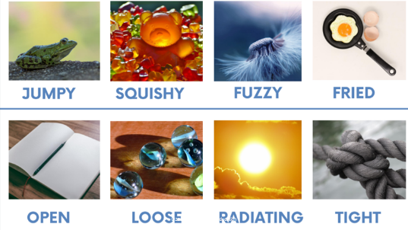 | What are our feelings/ emotions? https://www.youtube.com/watch?v=1S0RKRRyqhQ  Guess the feelings?  https://www.youtube.com/watch?app=desktop&v=dOkyKyVFnSs  Emotions and the Brain  https://www.youtube.com/watch?app=desktop&v=xNY0AAUtH3g&t=2s  Meet Riley s Emotions  Meet Riley's Emotions.!!! A still from Inside Out, one of the most amazing movies from Pixar  www.youtube.com  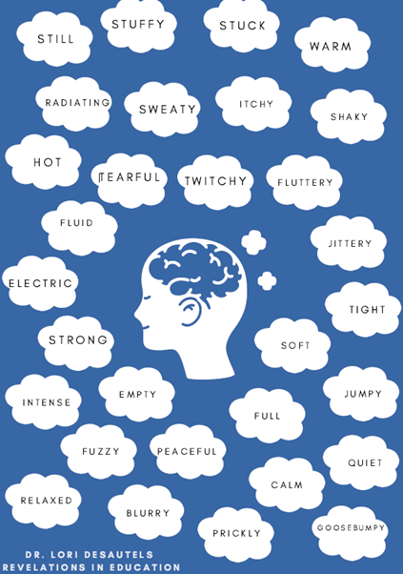
Brain and Body States and our Negative Bias | We discuss how our brains and bodies are changing all day long! Sometimes we are feeling calm, then irritated, angry, calm again and back and forth! Our brains are wired with a negative bias and therefore it is so common and normal to feel negative emotion. That emotion is there for our survival! Are you above, on or below the line?  We made stomachs and hearts and talked about the sensations we feel in these places. Students are also able to place their hearts and stomachs above, on or below the line. | Conscious Leadership  https://www.youtube.com/watch?v=fLqzYDZAqCI  What is our Negative Bias?  https://www.youtube.com/watch?v=3ThUrVXz9j0- fourth grade  https://www.youtube.com/watch?v=fLqzYDZAqCI  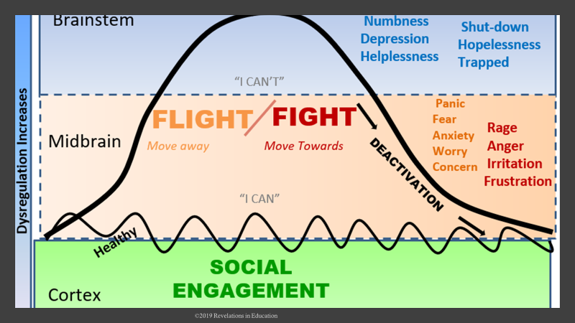  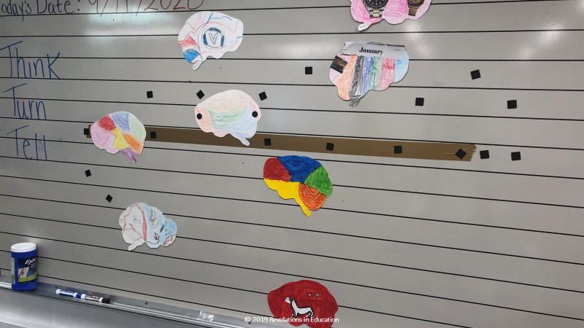
Brain and Our Thoughts | Questions for Our Brains  1. Why do you think our brains look at the bad things before we look at the good things?  2. Why do we pay more attention to negative emotions than positive emotions?  3. Do you think we can change how we think and feel on purpose? How would we begin to do this?  4. Let’s talk about Practiced Thinking!! What could this be? Could it be like a habit? Could your feelings and thoughts be habits too? Do other people influence how we feel and think?  5. Brain Intervals and Focused Attention Practices help to shift our thoughts before we say or do something that feels negative. | Look at this!!!  https://www.youtube.com/watch?v=kO1kgl0p-Hw  The Learning Brain  https://www.youtube.com/watch?app=desktop&v=cgLYkV689s4  Real Neurons Firing in the Hippocampus  https://www.youtube.com/watch?v=j7aOwjGLOq0  Patterns of Neurons Firing  https://www.youtube.com/watch?v=t3TaMU_qXMc  https://www.youtube.com/watch?v=m0rHZ_RDdyQ
Brain and Memories  What are memories? | We begin this section with understanding that memory happens everywhere in the brain and in the body! We have memory in the frontal lobes, in the amygdala area (hippocampus) and in our bodies. Some memories we remember because they are emotional memories. Other memories land in our bodies but we do not consciously remember them. These body memories or implicit memories are unconscious. They can be brought to life with different sounds, tones of voice, colors, objects that remind us of an emotion we felt with that long time ago memory! | https://www.youtube.com/watch?v=yOgAbKJGrTA  Brain Test for Memory- this could be a fun interval too!  https://www.youtube.com/watch?app=desktop&v=YZUiJLi7zow&feature=youtu.be  Ballerina remembers her dance! https://www.youtube.com/watch?app=desktop&v=6-j5yeRDBaU  University of Washington Neuroscience for Students  https://faculty.washington.edu/chudler/words.html  The Chunking Trick | Brain Games - YouTube  Play along with these few memory tests to find out how good your memory is and how you can improve it. Subscribe: http://bit.ly/NatGeoSubscribe About Brain...  www.youtube.com  We will have a little fun tomorrow with our brain intervals!!  https://faculty.washington.edu/chudler/words.html  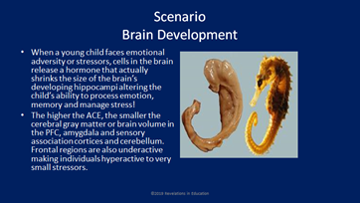
Brain Advertisements | In this lesson, we create advertisements for our brains. We explore ads and discuss how our strengths in all areas of our life need to be addressed and highlighted. We used the following questions as prompts.  Questions for Our Brain Advertisements!  - What are the best parts of my brain?  - What am I good at?  - I have lots of feelings you might need! Here are a few!  - My imagination is strong!  - I love to learn new things!  - I am a talker and a good friend!  - I love different foods!  - I am a good friend!  - I love different sports!  - Music is my thing !  - I am quiet and am always listening to thing around me  - My brain has lots of memories if you need one! Here are a few!  - My brain feels sadness a lot so if you need a little sadness, I have some to share!  - My brain has some anger to share , if you need some!  - I have excitement to share!  - My brain is good at feeling worried and scared so if you need some , I can help you out!  - I love art of all kinds!  - I am great at finding lost things!  - My brain loves animals so if you need a little more animal love, I am the brain you want!  - My brain loves books so if you want to read more I can help!  - My brain loves gaming! What do you need?  4th grade https://www.youtube.com/watch?v=KhZrQQeZ0WA&list=PLivjPDlt6ApQhuYe9r7EVeWMGXJWAZsNw&index=58 | We began sketching our brain advertisements with pencil before we created these with color and shapes.  Following our completion, we walked around in a carousel format and learned about each other and our brains. We played music and when the music, stopped we studied the brains of our classmates. We provided questions and feedback as we learned of each other’s strengths! 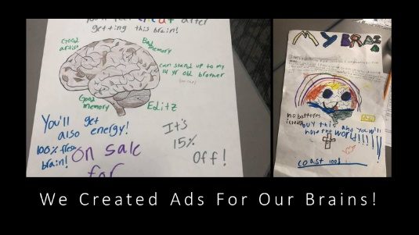  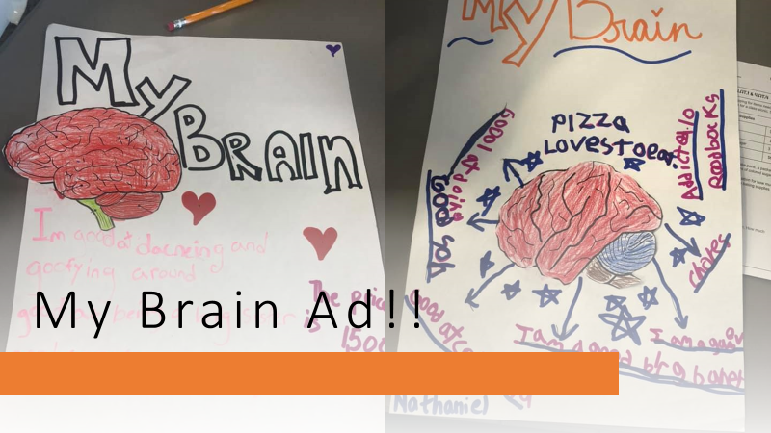
Talismans | Talismans provide connection to each other and our schools. They represent touch points, and each student created a talisman before they left school with colors, textures and notes and affirmations of encouragement from their classmates. 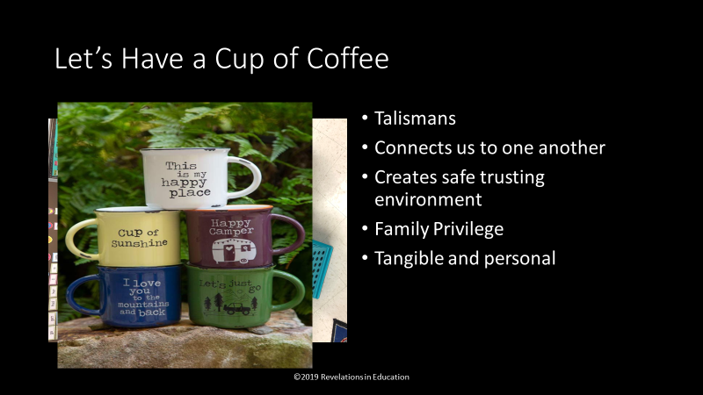 | 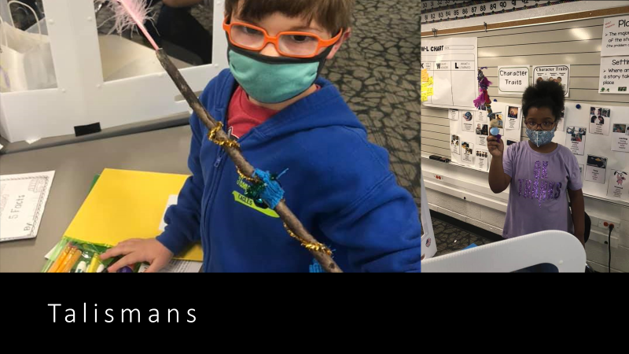
Rhythms | In utero, we develop through rhythm, movement, sound and vibration. Our development relies on the rhythms of life around us. Rhythm is regulating and we tried out drums where we mirrored each other’s rhythms. We live I n rhythms, sleep in rhythms, eat in rhythms and move in rhythms. | Rhythm ideas to begin or end each day of class or class period.  Use red cups, drums, bodies, paint sticks, etc.  https://www.pinterest.co.uk/SaraMullett/rhythm-games-activities/?autologin=true  https://www.youtube.com/watch?v=Y5kYLOb6i5I  https://www.youtube.com/watch?v=lmfKL9FOrLY  Our Own Lisa Beal from Indianapolis  https://www.youtube.com/watch?v=HaBUCIhaYSQ  Emotional Contagion! https://www.facebook.com/6812879574/videos/873755669781929/  https://www.youtube.com/watch?v=LOS0kA_O6IQ  Amazing four-year-old drummer  https://www.youtube.com/watch?v=pUcVA9BnSCY  Best street drummer- https://www.youtube.com/watch?v=FqJdzYY_Fas  Can we drum with them? Can you find your own rhythm?
Amygdala Bags and How I Calm | Amygdala bags are our calming bags we can use anytime we feel we need to relax or chill. We might also want to pull one item of our amygdala bag if we want to take a break or we are celebrating something we have accomplished. As a class we share and discuss the different items that feel calming to our nervous systems. We used balancing birds, yarn balls, scented oils, and scented hand sanitizer. | 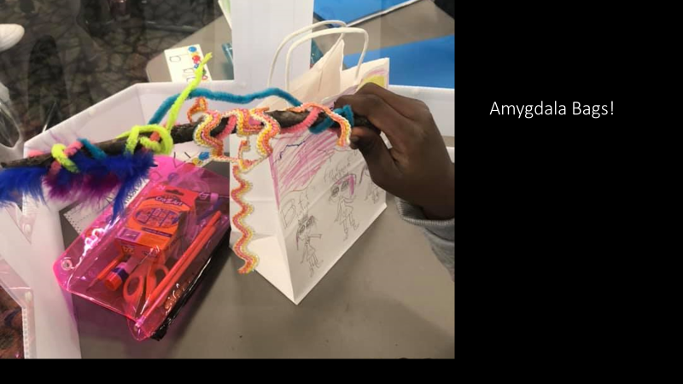
Focused Attention Practices and Tapping | EFT or tapping is one of the most powerful ways to use our breath and movement in calming our nervous systems. When we tap 10 to 15 times on each meridian point, we are activating those nerve endings as they travel to the limbic areas of the brain and calm the amygdala. We can implement tapping one on one with students, whole groups, small group and our goal is for students to use tapping on their own when they begin to feel anxious or dysregulated. | 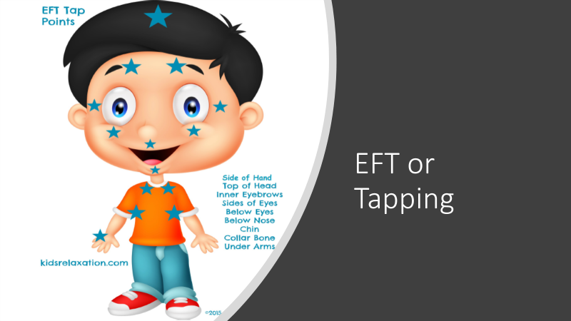
The Garden of Our Brains  Review parts and function of the brain as we compare our brains to gardens  We will explore how plants respond to environments. This activity is several weeks long and the students will record their observations as they notice changes in the plants each day. | Did You Ever Grow Anything in the Garden of Your Mind?  1. How are our brains similar to gardens?  2. What do plants need to grow?  What do brains need to grow?  3. What do you think thought seeds might mean?  What are feeling seeds?  4. What would you need to think about, and have as you plant your garden?  What would you need as you think about healthy brains and bodies?  - Let’s plant a garden in our classroom and in our brains and watch it grow!  - Our gardens need water, sunlight, and good soil. They may need shade and a protective fence?  - Keeping a journal, which is a touch point keep track and share some of the following provocations…  - Who watered you this week?  - Who is your sunlight? Who can see the best and brightest in you when you or others cannot?  - What places help you to feel safe? What people?  - What sounds? What types of rooms or outdoor areas?  - Who protects you? What do you do to self-protect? | Your Mind is Like a Garden-  https://www.youtube.com/watch?v=yV_E9ZQF0UE  Mister Rogers- https://www.youtube.com/watch?v=OFzXaFbxDcM  Bully A Plant: Say No To Bullying  Plants have feelings, just like people. So, what happens when you feed one plant with compliments and another with negative remarks? Watch how we got students involved in a social experiment to raise awareness on the effects of bullying. #SayNoToBullying  Student's Science Project Experiments On Bullying Plants  CBS2's Ali Bauman has the latest on a unique science project that looked at the effect bullying a plant has on its life.
Review Neuroplasticity | - Video on neuroplasticity/ Backwards Brain bicycle  - What would you like to try this week and change up?  What creates new neural pathways in our brains?  How can we change up old habits of feelings, thoughts and behaviors?  What makes this so hard? | Backwards Brain Bicycle https://www.youtube.com/watch?v=MFzDaBzBlL0&t=413s
Rubber Bands and Our Brain States | With a jar of rubber bands, students can choose a rubber band that aligns with their brain state throughout the day or class period.  Rubber Bands and Brain States  - Share a bag of rubber bands with the class from all shapes and sizes and ask the students how the rubber bands resemble their brains? Students could draw the shape of the band and share the “why” of that brain state.  - Students choose a size, thickness and color of a rubber band and drew and shared their own brain states! They then wrote about how they came to that brain state and what about the morning or evening before had led to their current brain state… This was such good information for us to know with regard to their state functioning.  - We then reviewed and talked about neuroplasticity and challenged them with a new yoga pose and they are to practice this week. We will check in each day and share the following week! A balancing pose is especially helpful and students can practice the balance as they add time on each day. | Discussion Questions  - Has anyone practiced? Does it feel different than last week? How? Our emotions are just like physical activities! The more time you spend being angry or sad or happy, the more often you will feel these emotions! How do we change a feeling? Sometimes we must choose a better feeling thought! When we practice that thought our feelings begin to change very very slowly but this takes practice!  - As we are patient with the tootsie roll sucker, think of three ways that feel good to you in your body to help you to feel calm when you are feeling anxious, angry and worried!  - Let’s create a wall of calming practices for our class to choose from when we are feeling dysregulated or anxious!  Your brain is plastic, and this is good for learning!  https://www.youtube.com/watch?app=desktop&v=5KLPxDtMqe8
Our Five Sense and Our Parietal Lobe | - Start with students trying to guess what object was in a bag by only being able to touch and what object was in a Tupperware container with small holes on the top by smell. Do you think you can tell what it is by using only one of your senses? Was one of your senses stronger than the other? Take one minute to observe and write down everything we notice in the classroom through sound, sight, smell, taste and touch.  - Discussion on our senses, how we use them and what part of the brain (Parietal lobe) figures out the messages we receive from these senses.  - Focused attention practice-trace our fingers, inhale up one finger, exhale down one finger etc. | - Focused attention practice-trace our fingers, inhale up one finger, exhale down one finger etc.  - Video- the parietal lobe explained & Video Phil Jackson/Kobe Bryant focused breathing  https://youtube.com/Kqc-u4NuPyw https://youtube.com/E78y66GEPvs
Review Sensations! | Choose word from the wall and draw it! Give it a color, line and shape and share where you feel it in your body!  Sensation Word Wall  Sensation Word Box  Cold/ warm/ hot/chilly  twitchy/ butterflies  sharp/ dull/itchy  shaky/trembly/tingly  hard/ soft/stuck/jittery/icy/weak  relaxed/calm/ peaceful  empty/ full  flowing/spreading  strong/ tight tense  dizzy/ fuzzy/ blurry  numb/prickly/ jumpy/owie/ tearful/ goosebumpy  light/ heavy/open  Tickly/ cool/ silky  Still/clammy/ loose
My Wise Self | Why is it important to create a wise self? Who would your wise self be?  Wise Self  In this lesson, we will create our wise selves… this can be a real person or a created version of someone or something you trust! It is important to share our feelings and thoughts with someone we trust, and this is an exercise in using our imagination and relying on our very own wise self!  What would my Wise Self Say?  What words of comfort do I want to hear from my Wise Self?  When we understand our wise selves, the way we talk to ourselves improves and feels calming and more confident.  What we can name, we can tame … Dr Dan Seigel | 